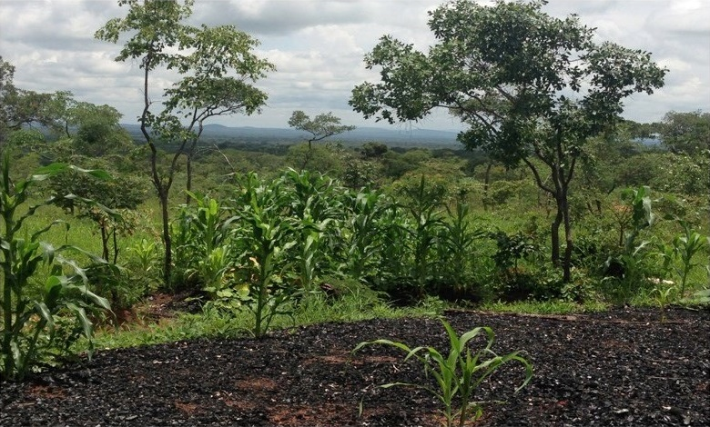

This publication was produced at the request of the United States Agency for International Development. It was prepared independently by The Cloudburst Group.

REPORT ON BASELINE FINDINGS
Community Forest Management Program

Photo Credit: Dr. Heather Huntington—The Cloudburst Group

Written and prepared by Dr. Heather Huntington, Aleta Haflett Starosta, Stephanie Fenner, and Ben Ewing, with contributions from Britton Gibson and Aidan Schneider.

Prepared for the United States Agency for International Development, USAID Contract Number AID-OAA-TO-13-00019, Evaluation, Research and Communication (ERC) Task Order under Strengthening Tenure and Resource Rights (STARR) IQC No. AID-OAA-I-12-00030.

Implemented by:
The Cloudburst Group
8400 Corporate Drive, Suite 550
Landover, MD 20785-2238

Report on Baseline Findings
Community Forest Management Program

JULY 2016

DISCLAIMER
The authors' views expressed in this publication do not necessarily reflect the views of the United States Agency for International Development or the United States Government.

CONTENTS

CONTENTS i
ACRONYMS ii
EXECUTIVE SUMMARY 1
1.0 EVALUATION PURPOSE & QUESTIONS 6
EVALUATION PURPOSE 6
EVALUATION QUESTIONS 7
DATA SOURCES 8
PROGRAM BACKGROUND 8
2.0 EVALUATION METHODS & LIMITATIONS 15
METHODS 15
SAMPLING METHODOLOGY 17
BASELINE DATA COLLECTION 18
CHALLENGES ENCOUNTERED 19
SAMPLE CHARACTERISTICS 20
3.0 FINDINGS—FOREST CONDITION 24
4.0 FINDINGS—FOREST LIVELIHOODS & DEPENDENCE 27
FOREST LIVELIHOODS & DEPENDENCE 29
5.0 FINDINGS—CLIMATE CHANGE & ADAPTATION 32
IMPACT OF WEATHER-RELATED CHANGE 33
RESPONSE TO CLIMATE IMPACTS 35
6.0 FINDINGS—FOREST GOVERNANCES & CONFLICTS 37
RULES 39
CONFLICT 40
7.0 FINDINGS—FOREST TENURE & ACCESS 43
FOREST TENURE & ACCESS 43
8.0 GENDER-SPECIFIC FINDINGS 49
ANNEX I—CFP IE DESIGN REPORT 52
ANNEX II—QUALITY CONTROL FORMS 53
ANNEX III—BALANCE & POWER 60
METHODS FOR ASSESSING BALANCE 60
POWER ANALYSIS 65
REFERENCES 67

ACRONYMS

μ mean
σ standard deviation
BCP BioCarbon Partners
CFP Community Forest Management Program
CO Contracts Officer
COP Chief of Party
COR Contracts Officer’s Representative
DD Difference-in-Difference
ERC Evaluation, Research, and Communication
FGD Focus Group Discussions
FPIC Free, Prior, and Informed Consultation
GCC Global Climate Change
GCCO Global Climate Change Office
GHG Greenhouse Gas
GMA Game Management Area
ha Hectares
ICC Intra-Class Correlation
IE Impact Evaluation
IQC Indefinite Quantity Contract
IRB Institutional Review Board
LTPR Land Tenure and Property Rights
LZRP Lower Zambezi REDD+ Project
MDES Minimum Detectable Effect Size
N Number of Respondents
NER Net Emissions Reductions
ODK Open Data Kit
PES Payment for Ecological Services
PFMP Participatory Forest Management Plan
RCT Randomized Control Trial
REDD+ Reducing Emissions from Deforestation and Degradation
STARR Strengthening Tenure and Resource Rights
USAID United States Agency for International Development
USG United States Government
VCS Verified Carbon Standard
ZAWA Zambian Wildlife Authority

EXECUTIVE SUMMARY

This Baseline Report analyzes baseline data from an impact evaluation (IE) of the United States Agency for International Development (USAID)-funded Community Forest Management Program (CFP) in Zambia. This baseline survey analysis has three objectives: 1) to improve understanding of the program context in the evaluation area; 2) to provide baseline estimates of key indicators and outcomes under investigation, which provides a benchmark for evaluating the eventual impacts of CFP; and, 3) to provide an exploratory assessment of baseline differences across the IE comparison (intervention) groups that will be used to measure CFP’s impacts. Zambia has the 4th highest percent of forest cover in Africa, and a top-5 global deforestation rate (UN-REDD, 2009), largely due to high demand for charcoal and unsustainable agricultural methods. Reducing Emissions from Deforestation and Forest Degradation (REDD+) is designed to reduce greenhouse gas (GHG) emissions by creating financial incentives for countries and communities to conserve indigenous forests, sustainably manage forests, and enhance forest carbon stocks, thereby protecting the carbon stored in forests. CFP aims to establish the largest REDD+ program in Zambia, covering 700,000 ha of forests in Eastern, Lusaka, and Muchinga Provinces. The program will be implemented from 2014–2019. The program is designed to reduce deforestation on customary lands and is defined by four primary objectives:
- Empower and equip communities to lessen the drivers of deforestation;
- Establish and improve forest and natural resource management plans;
- Promote alternative livelihoods to unsustainable charcoal and timber production; and
- Implement pay-for-performance and/or revenue-sharing programs for forest conservation and carbon sequestration.
CFP is of interest to USAID as a vehicle for learning about best practices in implementing REDD+ programming. An evaluation of CFP will provide USAID with better information on climate change, forest governance and land tenure and property rights (LTPR) within the context of REDD+ and will inform program design and influence policy. The IE is designed as a quasi-experimental Difference-in-Difference (DD) study that compares CFP treatment sites in Nyimba, Mambwe, and Lundazi Districts to control areas in these same districts. Although there is an underlying design behind the data collection, DD relies on statistical corrections to ensure that the evaluation design is valid.
USAID’s E3/Global Climate Change Office (GCCO) and E3/Land Office have engaged The Cloudburst Consulting Group to conduct an IE of CFP. USAID’s primary learning objectives for the CFP IE are:
- To understand how REDD+ programs impact LTPR and related livelihoods, either positively or negatively.
- To learn about what aspects of REDD+ programming are most effective in incentivizing long-term carbon sequestration and reduced GHG emissions from forests and landscapes.
Given the design and implementation of CFP, the evaluation measures the impact of CFP’s “bundle of interventions” rather than a specific intervention. In line with USAID’s Climate Change and Development Strategy, conducting this IE will allow the Agency to assess the success, scalability, and replicability of CFP’s approach.
In particular, the evaluation focuses on understanding climate change mitigation and the drivers of degradation and deforestation in the study area. It will investigate whether CFP builds the capacity of communities and local institutions to manage their forests sustainably and to reduce emissions. Additionally, survey instruments are designed to explore the benefits that communities identify as effective incentives for the adoption of behaviors that reduce deforestation, degradation, and GHG emissions. Because REDD+ relies on changing how communities access and use forest resources, the evaluation will examine how and to what extent REDD+ programming changes forest access, and what impact these changes may have on local livelihoods that are dependent on forest access. Finally, the study will attempt to uncover differential impacts or unintended program consequences across key subgroups, specifically women, youth, and poor households, and determine whether REDD+ benefits reach those who are most adversely impacted by the perceived loss of unrestricted access to forest resources. The specific research hypotheses of the impact evaluation are detailed below in Table 1.
Table 1—RESEARCH HYPOTHESES
 | Level of Measurement
Hypothesis | Community | Household | Intra-household
Greater perceived value of forests and forest resources | X | X | X
Improved local capacity to sustainably manage forests | X | X
Equitable benefit sharing and distribution across key subgroups, including women, youth and other marginalized groups | X | X | X
Reduced incidence of forest and related conflicts | X | X | X
Improved climate change adaptation, increased knowledge and awareness of deforestation and climate change | X | X | X
Improved transparency, accountability, and representativeness of legal and customary forest governance institutions | X | X | X
Greater perceived tenure security and improved protection of community land and natural resources. | X | X | X
Improved women’s voice and empowerment | X | X | X
Reduced incidence of community land expropriation by the government without adequate consultation and fair and timely compensation | X
Improved natural resource conditions, including reduced levels of deforestation, degradation. | X | X | X
Greater capacity for communities to negotiate mutually beneficial contracts between communities, the state, and private sector investors | X
Improved livelihood, development and welfare outcomes | X | X | X

This report presents a summary of several aspects of the baseline data collected from both treatment and control communities, includes details on sample characteristics, forest condition, climate change and adaptation, forest tenure and access, and forest governance and conflict. The baseline data consist of seven sources of primary community and household level data, including 4372 head of household respondents, 820 wives, 280 headmen, 240 forest key Informants, 80 focus group discussions (FGDs), 40 participatory mapping exercises, and six surveys with chiefs. The data was collected across 280 communities (167 treatment and 113 control) in Nyimba, Mambwe and Lundazi districts from March–May of 2015.

PERCEIVED FOREST CONDITION
There was a general consensus among Forest Key Informants (FKI) that forest conditions had declined or stayed the same over the last 3 years. Indeed, the results from the head of households and wives’ survey corroborate the FKI findings and show that forest degradation represents an important concern in the study area. Over half (54%) reported a forest with worsening conditions, while nearly 30% reported conditions had stayed the same. Although 62% (2471) of household respondents said that the forests they access were in ‘good’ or ‘very good’ condition, 25% (1021) rank forest condition as degraded, and over half of respondents 55% (2200) note that the trees, undergrowth, and the capacity of the forest to provide resources for the community has worsened over the past 3 years. Responses across heads of households and wives are similar, suggesting that men and women have similar perception of forest conditions., Forest condition data is based on household perception rather than transit walks or remotely sensed imagery, primarily due to lack of funds for additional types of data collection.

FOREST LIVELIHOODS AND DEPENDENCE
Forest livelihoods and dependence vary across households. Approximately 15% (655) of households in the sample are not dependent on the forest for consumption or income benefits; however, 84% (3468) depend on the forest for consumption, and 19% (847) depend on the forest for income. The most common forest products collected for income, as reported by head of households, are charcoal, mushrooms, and fuel wood. The most common forest products collected for consumption are fuel wood, wood for poles, and fibers, followed closely by mushrooms.
Despite a majority of households’ reporting that their perceptions of forest conditions have worsened, 59% (160) of headmen/women said that forest degradation was not a problem facing their community’s development. Similarly, 59% (2573) of households did not identify forest degradation as a problem for their households. Respondents were also asked to rank the five most important community assets from a list that included, among other things, forest resources, clean water, jobs, school, and agricultural land. The findings are similar across households, headpersons, and wives. The assets most commonly included in the top five were health clinics, clean water, and tarmac roads. For household respondents, forest resources were ranked the lowest of all eleven assets.

CLIMATE CHANGE AND MITIGATION
Climate change is perceived to be a larger threat to community health and development than forest degradation or deforestation. Seventy-nine percent (214) of headmen ranked changes in regular rainfall patterns as one of the top five problems facing their village, and 21% (58) ranked rainfall changes as their biggest problem. Only poor crop yields was ranked as the most important problem more often than rainfall (32%, 88), and the two are closely linked. Thirty-one percent of headmen believe changes in temperature are one of the top five problems facing their community. Fifty-one percent (2229) of household respondents say that changes in rainfall patterns or temperature are the largest problem facing their village development. In comparison, 19% (842) of respondents said that deforestation or degradation is the biggest constraint to community development.
The importance of forests for mitigating climate change does not appear to be well understood by respondents, nor do forest resources appear to be prioritized as highly as other community assets.

PERCEIVED TENURE AND ACCESS
The baseline findings suggest that most people feel fairly secure in their rights to forests, although a significant minority report perceived tenure insecurity. Heads of households, wives, and headmen appear relatively confident that their village’s forested land will not be encroached upon by any party in the next three years. The category of greatest concern to respondents is that the chief will reallocate or take land without village consultation—this is expressed by 25% (1091) of households and 25% (69) of headmen. Wives reported the greatest threat of encroachment from the chief or government. Twenty-two percent (153) of wives believe that the chief encroaching their forestland is likely, highly likely, or currently happening. Regardless, over half of all headmen believe that encroaching upon their customary forestland in the next three years by investors, government, the chief, or elites, is “impossible.”

FOREST GOVERNANCE AND CONFLICT
Conflicts about forestland, access, or resources are extremely rare in the study area. Ninety-eight percent (4246) of household respondents report that their households had not experienced any disputes over use or access to a forest in the past 12 months. Overall, 77% (3336) of heads of households are satisfied with the way that local leaders resolve conflicts and govern forest resources, as well as rules that govern forest access and use. These assessments generally range from 72-78% depending on questions about fairness of use, fairness of access, transparency, etc.

KEY SUBGROUP DIFFERENCES
Female-headed households (FHH) do not report being worried about forest or land encroachment from people outside of their extended family, including other villages, the government, or investors. However, they place less value on the forest and are less satisfied in forest leadership. FHH are also less likely to report knowing about the existence of forest meetings, forest management groups, and village forest committees, perhaps indicating less awareness of these institutions by women. While female-headed households have fewer fields than male-headed households, they are also less satisfied with land rules and leadership.
The exploratory analysis reveals mostly similar responses between youth respondents and the rest of the sample on key indicators of interest. However, youth respondents rank women and the village as a whole lower on the ladder of power (a measure of which individuals or groups have the most decision-making power in the village) for land related decision-making, although there is not a significant difference on the ladder of power for forest use and management. They are also somewhat more worried about the various encroachment scenarios with respect to farmland but not forests.
Poor households’ responses are also generally similar to the average household response with respect to forest and land variables. However, this subgroup is less concerned about forest degradation and less likely to know about the existence of village forest and land management groups. Poor households also rank women and the village as a whole lower on the ladder of power for land related decision-making.

BALANCE AND POWER
Annex III contains a section on balance and power based off of BCP’s final treatment communities. Due to programming changes, there have been important changes in the designation of treatment and control communities since the original design report. These issues are described in more detail in Section 2.0. However, overall, the sample is balanced across key outcome and control indicators.
This report also updates the original power calculations from the design report to reflect the baseline data collection. The updated power analyses indicate the study has sufficient power to detect changes across key outcome variables. The updated power analysis also shows that the evaluation is likely to be able to detect changes in the 3% to 22% range, with an average of 8%. By this measure, the IE is meeting design expectations and the study is sufficiently powered to detect small to moderate-sized, policy-relevant effects at the household level.

1.0 EVALUATION PURPOSE & QUESTIONS

EVALUATION PURPOSE
This report presents results from the baseline data collection completed as part of an impact evaluation (IE) of USAID's CFP in Zambia being conducted under the Evaluation, Research, and Communication (ERC) Task Order under the Strengthening Tenure and Resource Rights (STARR) IQC Contract. CFP is a central initiative under USAID/Zambia’s Global Climate Change (GCC) portfolio. USAID/Zambia has awarded a Cooperative Agreement to BioCarbon Partners (BCP) to implement CFP to initiate the largest REDD+ program in Zambia by supplying $14 million over five years of what is projected to be an approximately $19 million undertaking within the same period.
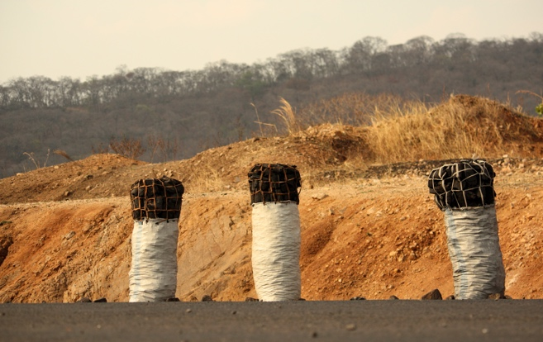
With approximately 50 million ha of forest, Zambia has the 4th highest percent of forest cover in Africa, and these forests are under significant threat due to high demand for charcoal and unsustainable agricultural methods. The country’s forests are disappearing at an estimated annual deforestation rate of 250,000–300,000 ha per year; this translates into a top-5 global deforestation rate and a top-10 global per capita deforestation emissions rate (UN-REDD, 2009). As the country continues to urbanize and industrialize, the nation is at risk of depleting its forest resources in fifteen years if the deforestation rate does not decrease (USAID/Zambia, 2013).
Charcoal for sale alongside a rural road
To address these challenges, CFP has been designed to reduce deforestation and carbon emissions in Zambia by improving livelihoods, income generation, and poverty reduction, as well as by increasing the number of hectares (ha) of forestland under improved management. CFP community-level activities will be implemented in at least 700,000 ha of forested areas in Zambia’s Muchinga, Lusaka, and Eastern Provinces from 2014–2019.
This IE is focused on CFP’s interventions in the Nyimba, Mambwe, and Southern Lundazi districts of Zambia’s Eastern Province. It is designed to rigorously assess CFP’s impact on a number of outcome indicators, including livelihoods, equitable benefits from REDD+, land and natural resource conflict, forest governance, climate change mitigation, and perceived forest condition. Given the design and implementation of CFP, the evaluation will measure the impact of CFP’s “bundle of interventions” rather than a specific intervention. As designed, this will be one of the first IEs conducted on the social and livelihood effects of a REDD+ intervention.

EVALUATION QUESTIONS
This IE tests a number of research hypotheses that follow from the evaluation objectives and program theory guiding CFP. These hypotheses form the basis for a series of development indicators that are measured at baseline and endline data collection, in order to assess the impacts of CFP on key development outcomes. The hypotheses investigated in this study are presented in Table 1.1 below.
Table 1.1—RESEARCH HYPOTHESES
 | Level of Measurement
Hypothesis | Community | Household | Intra-household
Greater perceived value of forests and forest resources | X | X | X
Improved local capacity to sustainably manage forests | X | X
Equitable benefit sharing and distribution across key subgroups, including women, youth and other marginalized groups | X | X | X
Reduced incidence of forest and related conflicts | X | X | X
Improved climate change adaptation, increased knowledge and awareness of deforestation and climate change | X | X | X
Improved transparency, accountability, and representativeness of legal and customary forest governance institutions | X | X | X
Greater perceived tenure security and improved protection of community land and natural resources. | X | X | X
Improved women’s voice and empowerment | X | X | X
Reduced incidence of community land expropriation by the government without adequate consultation and fair and timely compensation | X
Improved natural resource conditions, including reduced levels of deforestation, degradation. | X | X | X
Greater capacity for communities to negotiate mutually beneficial contracts between communities, the state, and private sector investors | X
Improved livelihood, development and welfare outcomes | X | X | X

DATA SOURCES
To test these hypotheses, the evaluation will utilize seven primary sources of community, household, and intra-household level data to investigate GCC and land tenure outcomes of interest. All of the original survey instruments described below were pre-tested and piloted prior to the baseline data collection. The evaluation team aims to conduct all quantitative instruments as panel surveys; this involves tracking the same respondents over time between the baseline and endline data collection.
The baseline data for the evaluation was collected from March–May 2015 and includes:
- Household survey data (N=4343)—The household survey was stratified to target female-headed households, youth, and landless groups. The CFP IE Household survey is based on the Rural Agricultural and Livelihood Survey (RALS), which is implemented by the Central Statistics Office (CSO) with support from the Indaba Agricultural Policy Research Institute (IAPRI).
- Wives survey (N=820)—The wives survey was administered to wives in male-headed households. It collects much of the same information as the Household survey to help document differences and similarities between women and men and their responses.
- Headperson survey (N=280)—A close-ended survey interview was conducted with the traditional leader (headperson) of each village in the study area.
- Focus group discussions (N=80)—The evaluation collected data from open-ended FGDs with women, youth, and landless groups in a subset of the villages involved in the evaluation. Two FGD were conducted in 40 villages.
- Participatory mapping (N=40)—As part of the qualitative data collection effort, the evaluation conducted an open-ended participatory mapping exercise with representative groups of men and women (separately) in each village.
- Forest key informant interviews (N=240)—A close-ended survey was conducted with a Village Forest Key Informant. The FKI was identified on a case-by-case basis, and the sample includes members of a Community Resource Board, forest guard, members of a Village Action Group focused on forest issues, and village elders.
- Chief key informant interviews (N=6)—The evaluation interviewed chiefs from the treatment and control areas across Nyimba, Mambwe, and Lundazi Districts, using a combination of close-ended survey questions and open-ended interview questions.

PROGRAM BACKGROUND
This section briefly outlines CFP program activities in Zambia and provides background on REDD+ in the study area. It highlights the specific interventions that are under investigation through the IE. As noted in the Introduction, given the design and implementation of CFP, the evaluation will measure the impact of CFP’s “bundle of interventions” rather than a specific intervention.

EASTERN PROVINCE
As shown in Figure 1.1, Eastern Province is located in the eastern region of Zambia, bordering Malawi. It represents a globally significant biodiverse landscape with large areas of intact forest. The climate is semi-tropical, with a single rainy season between November and April. Rainfall varies between 500–1400 mm each year. There is significant temperature variation—average temperatures range from 6–26 degrees Celsius in the cold season (May–July) and 17–35 degrees in the hot season (September–October).

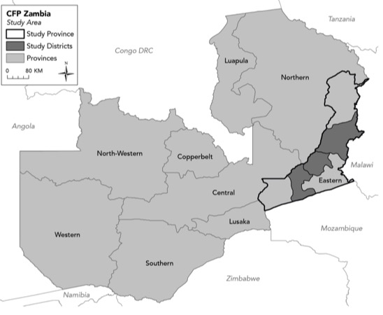
Approximately 1.5 million people live in Eastern Province, and 87.4% reside in rural areas. The majority of households live without electricity or public water or sanitation services and are primarily reliant on subsistence agricultural activities. The average household landholding is 2.54 ha, with 1.86 ha under cultivation. The main subsistence crops include maize, cotton, and groundnuts, where harvested crops make up 64% of total household income. Other sources of income include off-farm income (21.9%), fruit and vegetable production (10.5%), and livestock sales (2.5%) (Tembo & Sitko, 2013). More than 75% of households are poor, living on less than $1.25 a day, and roughly 60% of the population is classified as living in extreme poverty (Tembo & Sitko, 2013).
Figure 1.1—Map of eastern province, zambia
The primary drivers of deforestation and forest degradation in the program area include wood extraction, agricultural expansion, and fires, as well as destruction by wildlife. Overgrazing by wildlife, including elephants and hippos, is a particular problem in the wildlife corridors of Eastern Province, where the CFP IE will take place. Wood extraction encompasses logging, collection of fuel wood, and charcoal production. Charcoal production is a significant driver of deforestation, providing livelihoods for producers in rural areas and low-cost energy for consumers in urban areas. It is estimated that the production, distribution, and marketing of charcoal provides livelihood benefits and income for over a half a million people across Eastern Province (Kalinda, Bwalya, Mulolwa, & Haantuba, 2008). Rural households often use charcoal to diversify their household income as a risk avoidance strategy for periods of poor agricultural production. At the same time, the increase in urban populations—

particularly low-income urban populations—ensures the demand for charcoal will continue to rise (Vinya, Kasumu, Syampungani, Monde, & Kasubika, 2011).

Agricultural expansion—or the clearing of land—is the second most frequent driver of deforestation in Zambia. Subsistence agriculture is the main source of food and income for the majority of Zambians (Ministry of Tourism, Environment and Natural Resources, 2002). The use of unsustainable cultivation practices, such as poorly executed slash-and-burn and overgrazing livestock, increase the time needed for deforested land to regenerate. Furthermore, growth in Zambia’s population creates an additional demand for increased agricultural productivity to meet the nation’s food needs. Government policies that incentivize the production of low-value cereal crops may further contribute to the clearing of forested land for agriculture.
view of Forest from Mambwe District Main Road
Wildfires are frequently used in Zambia to hunt wild game, clear fields for cultivation, control brush, and manage pastures. These fires are often not well managed and represent a driving factor behind forest degradation in Eastern Province. Wildfires, particularly late in the dry season, can be devastating to forest cover, as they slow the regeneration and survival of young plants.
The fundamental cause of deforestation in Zambia is attributed to extremely high rural poverty. Poverty leads to a high dependence on natural resources for day-to-day survival. This is exacerbated by high demand for charcoal from urban areas due to the lack of affordable alternative energy sources.

REDD+
In an effort to reduce deforestation in Zambia and mitigate carbon emissions, the United Nations (UN-REDD+ program) and the United States Government (USG) (through CFP), are supporting the development of a national REDD+ strategy in Zambia, as well as preparation for the country’s participation in pay-for-performance programs. Reducing Emissions from Deforestation and Forest Degradation (REDD+) is a local, national, and global initiative to create a financial value for the carbon stored in forests, offering incentives for developing countries to reduce emissions from forested lands and invest in low-carbon paths to sustainable development. REDD+ goes beyond deforestation and forest degradation and includes the role of conservation, sustainable management of forests, and enhancement of forest carbon stocks (USAID/Zambia, 2013).
REDD+ programs constitute a form of payments for ecosystem services (PES)—a rapidly proliferating set of market-based or fund-based, incentive-oriented interventions in which individuals or communities are paid by a specified buyer, via a contract mechanism, for land use activities that maintain the flow of a clearly-defined environmental service relative to a pre-determined baseline (Jack et al., 2008; Engel et al., 2008).
REDD+ is potentially promising as a tool for GHG mitigation and forest conservation, in which developing country governments and organizations are compensated for verified reductions in emissions from forest loss and degradation activities. In this sense, REDD+ seeks to incentivize conservation by giving standing forests an economic value that more closely rivals that which accrues from forest exploitation and conversion.
REDD+ strategies offer great promise for synergy in achieving diverse carbon emission mitigation, forest conservation, and poverty reduction goals (Campbell 2009). However, there are also many concerns around its implementation. These include the assumption of effective governance and equitable property rights in recipient countries that is often lacking in real world contexts. REDD+ also has the potential to generate unintended negative impacts on social equity and livelihoods. The approach has also faced challenges regarding inaccurate environmental service valuation and its capacity to create sustainable and effective markets (Mahanty, Suich, & Tacconi, 2013; Corbera, Problematizing REDD+ as an experiment in payments for ecosystem services, 2012; Corbera & Schroeder, Governing and implementing REDD+, 2011). Other critics have drawn attention to the continuing dearth of evidence about the impacts of PES interventions more broadly (Pattanayak et al., 2010).
REDD+ requires developing country governments to devise a national approach to planning for REDD programs and to develop a country-wide strategy that includes, among other issues, land-use planning, clarifying tenure rights to forest lands and carbon amongst different national stakeholders, establishing a carbon accounting system, and developing mechanisms for benefit-sharing among individuals and organizations from local levels to the national scale. Governance issues have remained a central focus for scrutiny—particularly given the involvement of a number of international and national actors with divergent and competing interests (Corbera and Schroeder 2011). The need for clearer articulation of security over land tenure has been increasingly recognized as an essential pre-condition for REDD+ implementation to be successful (Larson, et al., 2013).
In many countries, the existence of overlapping formal and informal tenure arrangements complicates this process, and, as such, REDD+ activities have highlighted a need to address long-standing tenure insecurities, especially with regard to customary claims to land and forest resources on the part of local communities. In this sense, REDD+ may also provide a window of opportunity for wider tenure reforms to take place, while also serving as a vehicle for increased safeguards over community rights (Larson, et al., 2013). However, while the links between tenure security and forest carbon outcomes are viewed as critically important, the processes by which REDD+ programs might effectively address tenure concerns and safeguard local communities’ rights to access and benefit from forest resources are not currently well-articulated (Naughton-Treves & Wendland, 2014).
Zambia’s large area of intact forest—50 million ha—and its high deforestation rate—estimated at 250,000–300,000 ha per year—are factors that have made the country a good candidate for REDD+ (FAO 2010). Development partners see REDD+ as an important opportunity to mitigate carbon emissions by reducing deforestation. A prospective evaluation of CFP and its impacts on tenure security and livelihoods will contribute to the policy discussion surrounding the challenges and benefits of REDD+ by providing the necessary data to address the questions and concerns outlined above.

program INTERVENTIONS
CFP is focused on strengthening the national REDD+ process by piloting innovative approaches to participatory forest management. The program seeks to identify strategies that reduce the drivers of deforestation, including inadequate participation of, and benefits to, communities involved in REDD+ activities. It aims to empower communities to lessen deforestation; establish and improve community forest management through participatory forest management plans (PFMPs); promote and enable alternative livelihood strategies that provide forest-dependent communities alternatives to the charcoal and timber harvesting; create pay-for-performance and/or revenue sharing programs based on measuring, reporting, and verifying forest conservation and carbon sequestering; provide households with information, technologies, and tools that help them achieve more sustainable livelihoods; and raise awareness, promote action, and dispel misconceptions that limit Zambia’s REDD+ potential.
BCP is a private firm responsible for the development and implementation of the CFP program in Zambia. BCP uses a hybrid business model for the implementation of REDD+. This involves the integration of a commercial structure to sell and market carbon credits with a grassroots model that involves working with local communities on forest conservation and management. As part of CFP, BCP will enter into partnerships with landowners, local communities, and government officials to protect forested landscapes in areas of conservation importance in order to reduce deforestation. In Zambia, BCPs’ REDD+ program represents a long-term investment, involving working with communities for a minimum of 30 years.
BCP’s REDD+ Project Model is comprised of six main components that are outlined below. The IE is focused on assessing the program’s impact for the bundle of Component 1, 2, and 3 interventions.

COMPONENT 1. STAKEHOLDER CONSULTATION
As a standard requirement for REDD+ programs, CFP requires a significant knowledge and outreach component. This includes promoting outreach and awareness about the program in accordance with the principles of obtaining free, prior, and informed consent (FPIC) and by identifying community needs and drivers of deforestation, as well as raising awareness about REDD+ and climate change.

COMPONENT 2. LIVELIHOOD IMPROVEMENT
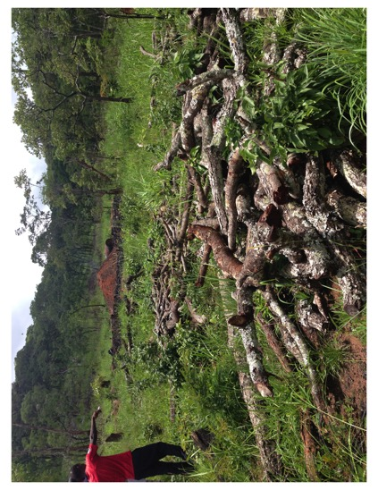
Following stakeholder sensitization in accordance with the principles of FPIC, BCP will enter into REDD+ implementation agreements with relevant stakeholders to the program. A key element of the REDD+ implementation agreement will be the collaborative development of a Livelihoods Interventions Plan (or Strategy). The aim of the Livelihoods Interventions Plan is to provide the community with tangible benefits that replace the income and/or livelihood benefits received from deforestation or forest degradation. There are a number of potential community-based mitigation and pay-for-performance initiatives that may be implemented as part of CFP, including eco-charcoaling, conservation farming, and eco-tourism. Livelihood activities are selected by each community on a community-by-community basis. For more information on possible CFP implementation initiatives, please see Annex I—CFP IE Design Report.
eco-charcoaling site

COMPONENT 3. FOREST MANAGEMENT
Forest management involves job creation and community capacity building for forest and fire monitoring and management. Illustrative activities include:
- Hiring and increasing the number of well-trained community scouts
- Establishing a communications network
- Increasing forest scout mobility
- Implementing controlled, early burns and fire breaks

COMPONENT 4. FOREST CARBON SCIENCE
The core climate science activities will include inventorying forest carbon, modeling cumulative deforestation patterns, and assessing soil carbon. BCP uses Geographic Information Systems/Remote Sensing (GIS/RS) to show the rate of historical deforestation and to track deforestation in program sites for the sale of future carbon credits.

COMPONENT 5. CARBON MARKET CREATION
CFP is currently being designed to comply with the Verified Carbon Standard (VCS), although on-going policy discussions at the national level may require CFP to comply with additional standards. VCS verification will not occur until several years into the program.

COMPONENT 6. POLICY AND ENGAGEMENT WITH THE GOVERNMENT OF ZAMBIA
The program will be aligned with the objectives of the Government of the Republic of Zambia’s National REDD+ Program, implemented through the Forestry Department.

2.0 EVALUATION METHODS & LIMITATIONS

METHODS
This IE uses a DD design that compares outcomes in the CFP treatment chiefdoms to those measured in control chiefdoms. The treatment and control chiefdoms are spread across Nyimba, Mambwe, and Lundazi Districts.
Difference-in-Difference (DD) is a strategy that uses data with a time and control group dimension to control for unobserved and observed fixed confounding factors. DD is one of the most frequently used methods for IE. In the context of the CFP IE, a DD method will compare the changes in outcomes over time between villages receiving the CFP interventions and villages that are not involved in CFP. Given the program implementation plan, a randomized control trial (RCT) or experimental design was not feasible for the CFP evaluation. There was also a lack of pre-existing village or household level data in the study areas to support a design informed by matching. The DD approach represents the next best quasi-experimental evaluation technique for analyzing the impact of the program.
DD enables analysts to take into account any differences between treatment and control groups that are constant over time, but are not attributable to the program itself, in the analysis of program impacts. This is an important strength of the method, because it controls for time invariant observable and unobservable differences between treatment and control groups that can otherwise confound the estimates of program impact. A useful implication of this is also that the treatment and comparison groups do not need to have the same pretreatment conditions, although they do need to experience the same broad trends (outside of the program intervention itself) over the time frame of the IE, for the DD to be valid. In other words, the control group must be subject to any broader influences that also affect the outcomes of interest that are experienced in the CFP sites in the absence of the program. This is called the “equal trends assumption”. Although the treatment and control areas can differ in their baseline characteristics before the implementation of the CFP program, they cannot be subjected to different trends in external influences during the evaluation period such that their trajectories are no longer similar, even in the absence of the program intervention. The key limitation to the validity of DD designs is, thus, that they are not able to effectively compensate for or eliminate the confounding effect of differences between treatment and control that change over time and also affect the outcomes of interest (Abadie 2000). This assumption represents the key limitation of DD—it cannot control for time-varying differences between the treatment and control groups. For example, if another donor initiated a REDD+ intervention in control sites, or there was a change in market demand for forest products that occurred only in the treatment or the comparison area, the DD would not be able to account for or control for the confounding influences of these events in the impact estimates that are obtained from the DD analyses.
The selection of the control group that serves as an appropriate counterfactual is critical to the validity of the study. The original design plan was to select control sites that resemble treatment sites on a series of relevant factors, including ecological zone, drivers of deforestation, community and demographics, chief’s approach to land tenure and forest management, and influences from other programs. However, a formal matching approach was not available to the team given the lack of data in the study area on most of these criteria.
Instead, the control areas were identified in collaboration with BCP, and the research team used control chiefdom recommendations from BCP during the original evaluation design stage. These control chiefdoms represented areas that BCP had considered for inclusion in the treatment group but that failed to meet the requirements for treatment due to (1) a lack of buy-in from chiefs and/or (2) logistical considerations regarding the timing of program roll out in those areas. Based on BCP’s scoping activities, the recommended control areas fit many of their criteria for a REDD+ site. However, the chief refused to participate in the program (Nyalugwe) or BCP determined that areas in Southern Lundazi would be phased in as potential treatment sites at some later date. However, following baseline data collection, BCP made a series of changes to their implementation plan. This resulted in a discrepancy between the IE design’s initial designation of sites into treatment and control. Specifically, the original IE design aimed to have a subset of treatment and control villages in both Mambwe and Nyimba, with Southern Lundazi serving as an additional control to the Mambwe areas. This original design was based on a concern that balance across the districts would be poor and that better control sites would be located within the same chiefdoms as treatment sites. However, due to BCP’s implementation shift, almost all sampled communities in Mambwe represent treatment villages, whereas the overwhelming majority of villages in Nyimba are designated as control. Southern Lundazi is now split between treatment and control sites. Despite concerns about balance, our analysis indicates that treatment and control areas are balanced across key household outcome and control indicators. A detailed discussion of the balance and power of the study based on the treatment and control designations can be found in Annex III.
Table 2.1 below displays the specific study site names and locations, and Figure 2.1 on the following page locates each treatment and control villages on a map of the Eastern Province of Zambia.
Table 2.1—Number of Treatment and Control Areas by chiefdom
District | Chiefdom | Treatment Villages | Control Villages | Total Villages
Nyimba | Luembe | 15 | 58 | 73
Nyimba | Nyalungwe | 9 | 64 | 73
Mambwe | Msoro | 83 | 6 | 89
Mambwe | Malama | 2 | 1 | 3
Southern Lundazi | Mwanya | 49 | 13 | 62
Southern Lundazi | Masemphangwe | 0 | 21 | 21
TOTAL |  | 158 | 163 | 321

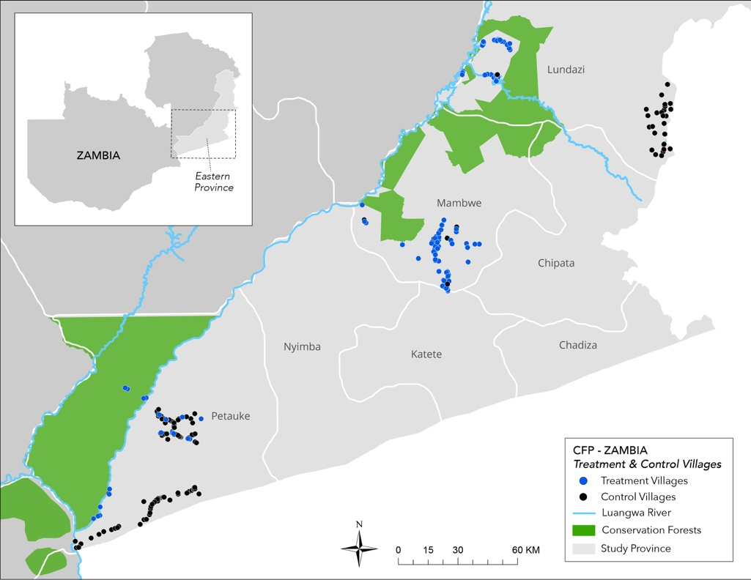
Figure 2.1 - locations of the study areas

SAMPLING METHODOLOGY
The hypotheses tested by the household survey are noted above in Table 1.1. The initial household sampling methodology was to conduct a large-N survey involving approximately 4500 respondents. The total number of villages expected for the study was 300 across the entire study area. Within each village, the study aimed to survey (1) the head of household from 15 households, (2) village headperson, (3) wives from three male-headed households and (4) a Forest Key Informant. The household, wives, headperson, and forest key informant surveys were collected through a cloud-based mobile data collection effort. 300 villages were selected at random from a list of villages generated through a community listing exercise conducted by the survey firm, and 15 respondents were selected randomly using a Python script and a list of household heads collected by the survey supervisors in each village.
The qualitative research strategy employed two data collection tools: FGDs and participatory mapping exercises. The FGDs covered 40 villages, both treatment and control. Key sub-groups of interest for the FGDs included women engaged in forest-based livelihoods (especially widows engaged in forest-based livelihoods), youth (income-earning and unemployed), and landless men and women. Each group discussion included six to eight pre-selected participants. Participants were recruited by enumerators with assistance from the village headman. To encourage discussion, to the extent possible, enumerators selected participants who were homogenous and had a high level of familiarity with other participants.
Participatory mapping was implemented in 20 randomly selected villages. The two groups of interest for the participatory mapping include a representative group of women and men, respectively, from each village. Each mapping exercise included six to eight participants selected by the enumerators, and the selection criteria prioritized heterogeneity of participants. A full discussion of sampling methodology can be found in the IE Design Report (Appendix I).

BASELINE DATA COLLECTION
A Zambian firm, Rural Net, conducted the baseline data collection in close cooperation with ERC. Enumerator training began with a training-of-the-trainers in Lusaka, Zambia, led by ERC’s Country Coordinator. Over six days, the program manager, field managers, and survey supervisors were trained on the household survey, wife survey, headman survey, forest key informant survey, sampling methodology, and electronic data collection using Open Data Kit (ODK). Feedback from the training-of-the-trainers allowed investigators to improve the survey instrument and further adapt it to the local context prior to enumerator training.
Enumerator training took place over eight days and consisted of two separate sessions, one for quantitative enumerators and one for qualitative enumerators. Seven days of training took place in Lusaka, with the final day in Nyimba, Eastern Province. The Rural Net Field Manager and survey supervisors led the training, with assistance from the ERC Country Coordinator. Training included a pilot exercise in Nyimba. Enumerators were trained on best practices for interviewing, the ethics of research with human subjects, electronic data collection devices, the household survey instrument, and the wife survey instrument. Both survey instruments were practiced in Chenyanja, the language spoken in Eastern province. Training contained lectures, role plays, and group exercises and provided four days for enumerators to practice the survey in small groups, share their questions and advice, and practice using ODK, the survey platform selected for electronic data collection.
Qualitative enumerators were trained simultaneously over an eight-day period, including two pilots, one in an agricultural community outside Lusaka and one in Nyimba. An ERC Research Analyst led the training. The qualitative team was trained in best practices for qualitative interviewing, the ethics of research with human subjects, and the various qualitative survey instruments, including key informant interviews, FGDs, community mapping, and the chief key informant survey.
The field team consisted of one field manager, eight supervisors, 48 enumerators, two auditors, and four qualitative enumerators. The ERC Country Coordinator worked alongside the team in Nyimba for the first two weeks of data collection. All enumerators were fluent in English and Chenyanja, and the majority had at least some post-secondary education.
In line with the requirements for human subjects protection, approval was received from the Clark University Institutional Review Board (IRB) in February 2015 and from the ERES Converge, a private Zambian IRB, in March 2015. The purpose of an IRB board is to ensure all human subject research is conducted in accordance with all federal, institutional, and ethical guidelines. In accordance with IRB protocols, informed consent was received from each participant after reading a statement about the purpose of the research, the content of the survey, any risks or benefits, and the time commitment. Participants were assured their participation was voluntary and could be withdrawn at any point and their answers would be kept confidential. Participants who agreed to participate in the research gave their written consent, either by signing or making a thumbprint on the consent form. Each respondent was left with a copy of their consent form, as well as information about the study and contact information for the Zambian IRB board and for Rural Net.
Quantitative and qualitative data collection took place between mid-March 2015 and mid-May 2015. The field team consisted of eight teams of six enumerators, at least one of whom was female, and one supervisor, who were responsible for surveying one village (15 households, plus three wives) each day. The team worked first in the Nyimba area before moving to Mambwe and Southern Lundazi. Data was entered directly into Android phones and downloaded and formatted into Excel spreadsheets.

DATA QUALITY
The CFP baseline data collection effort utilized the following quality control measures: audits, spot-checks by supervisors, site visits by field managers, and weekly back-checks by ERC staff. In the field, 15% of surveys were audited by auditors hired and trained by the survey firm. Auditors administered one of three 20-minute audit surveys to households. Auditors were provided with the original enumerator answers to assist with probing in case of a mismatched answer but not the name of the enumerator being audited. Each enumerator was audited a minimum of three times each week, and auditors were instructed not to discuss the content of the audit questionnaire or which villages or households they interviewed during the survey. Each audit question was given a point value for each type of error, points were tallied at the end of each audit, and errors were discussed one-on-one with the auditor and the enumerator once a week.
Each enumerator was spot-checked by their supervisor a minimum of five times each week, and one of those times a supervisor was present for the entire interview. Spot-checks have an accompanying checklist through which supervisors score the enumerator from 1-5 on their surveying technique, including the informed consent process, probing ability, and relationship with the respondent. The checklist was designed by ERC, and the scores could be used for incentive or reprimanding as the firm saw fit. The checklist is included in Annex II as well as with an audit form for use with respondents after an enumerator completed an interview. In addition to supervisor checks, the field manager randomly visited each team at a survey site once a week to observe the enumerators and supervisors and confirm compliance to survey methodology. Feedback from the field manager and supervisors was continuously used to improve enumerator performance and discourage data falsification.
Finally, the most thorough checks were back-checks conducted by the ERC Country Coordinator. These checks were conducted on 100% of all household surveys using STATA, and results were compiled and shared with the survey firm daily for the first two weeks, then weekly in the remaining weeks. The back-checks compared survey responses by enumerator to search for patterns indicating data falsification or systematic errors that should be corrected, including short survey times, missing responses, a low average number of “other, specify” responses or multiple selections, or a low average number of rows completed on each roster.

CHALLENGES ENCOUNTERED

SMALL VILLAGES
Sixty-nine villages in the survey sample had fewer than 15 households. To meet the target sample size, small neighboring villages were clustered together and surveyed as a single village.

DIFFICULT TO ACCESS VILLAGES
Eighteen village clusters in Nyimba are located across the Lundazi River. Accessing these villages requires crossing the river on small canoes and walking for as many as ten kilometers through forests. Two all-male teams were sent to survey these difficult to reach villages, and they traveled with an armed Zambian Wildlife Authority (ZAWA) guide, in case of threats from wildlife.
In addition to these villages, unseasonably late rains led to many washed-out roads, increasing the number of days required to complete data collection.

ENUMERATOR ATTRITION
Rural Net lost eight enumerators in the first month of surveying, primarily due to personal reasons. 15 additional enumerators were recruited and trained for five days by the Project Manager and ERC Country Coordinator and sent to join the team for data collection in Mambwe. Quality control checks did not reveal any differences in the data collected by the new staff, and there is no evidence that enumerator attrition negatively affected data quality.

LACK OF COOPERATION FROM VILLAGES
Despite the introduction script read by the supervisors to the village headman making no mention of BCP, Rural Net and the survey teams were often suspected of working with BCP. Villagers were aware that BCP had been in their communities asking questions about the forests, and there were concerns about BCP activities in some of the sample sites. As a result, three communities refused to allow Rural Net to survey at all, and an additional 29 households refused to participate.

SENSITIVE SURVEY QUESTIONS
The survey instrument contained some questions about engagement in forest-related activities that are against ZAWA or Department of Forestry regulations. These include questions about selling charcoal, harvesting certain types of timber, and hunting wildlife, including fish and bushmeat. Both activities are illegal without permits. As a result, households may underreport their engagement in these activities. Enumerators were given specific training in how to ask sensitive questions, and respondents were free to refuse to answer any of the questions.

SAMPLE CHARACTERISTICS

HOUSEHOLD & WIVES SURVEY
The sample for the household survey includes 4343 households and 820 wives. The sample is disaggregated by subgroup in Table 2.2.
Table 2.2—Basic Household Survey disaggregation
All | Treatment Status |  | Gender of Household Head |  | Age Group of Household Head
 | Treat | Control | Female | Male | <36 | >=36
4343 | 2250  (52%) | 2093  (48%) | 1225  (28%) | 3117  (72%) | 2041  (47%) | 2302  (53%)

The district and chiefdom breakdown for the household sample are provided below in Table 2.3. In terms of ethnicity, Nsenga (41%) represents the largest tribe in the study sample, and the second largest group is Kunda (20%), followed by Chewa (16%) and Bemba (13%). The majority of households are Christian (93%).

Table 2.3— district and chiefdom breakdown for the household sample
 | N (%)
District
Nyimba | 1929 (44%)
Mambwe | 1318 (30%)
Lundazi | 1123 (26%)
Chiefdom
Luembe | 998 (23%)
Nyalungwe | 930 (21%)
Malama | 39 (1%)
Mwanya | 650 (15%)
Msoro | 1264 (29%)
Masemphangwe | 491 (11%)

Table 2.4 breaks down a few demographic characteristics of the household survey and wife survey sample. As one would expect, education levels are low, and are lower for wives than for the household as a whole. In 18% of households (N=706), adults have no formal schooling, nor do 19% (155) of wives. Seventeen percent (674) of households have at least one member that has completed Grade 7. Youth household heads are more likely to have completed Grade 7 than older households.
Like most rural Zambians, survey respondents live in villages comprised of a few family groups, and mobility is low. Many, particularly household heads, live in the same village where they were born. Of those not from their village of residence, more than two-thirds were born within the province, and over a quarter were born in the same chiefdom. The survey area consists of both matrilineal and patrilineal tribes, but the majority of household land is passed through the husband’s family. The tribes most likely to pass land through the wife’s family are the Nsenga and the Chewa, while all other tribes are patrilineal.
Households in the sample earn most of their living from small-scale agriculture and have limited income from other sources, including from forest-related activities. Poor households report higher levels of non-farm income than non-poor households, such as performing ganyu—a form of hired labor—on other people’s farms. Fifty-nine percent (596) of poor households earn more than 2,000 ZKM annually. This suggests that poor households are more likely to engage in off-farm livelihood activities to supplement smaller agricultural incomes. Female-headed households report much lower rates of off-farm income. Eighty-seven percent (971) of female-headed households (FHH) earn 2,000 ZMK or less.
The most common source of off-farm income is work on other people’s farms. The most lucrative sources for off-farm income are salaried jobs, which earn an average of 3,271 ZMK annually (sd=3,449), and jobs in the tourism sector, particularly at lodges or as guides in national parks, which earn an average of 2,328 ZMK per year (sd=4,848). These sources of income are uncommon, however, and only 2% (101) earn tourism-related income and 8% (334) earn income from a salaried job.

Table 2.4— HOUSEHOLD and wife CHARACTERISTICS
 | N (%)
Mean age of household head | 40.0
Mean age of wife | 32.3
Mean household size | 5.2
Household head is monogamously married | 2790 (64%)
Average number of years of education of the highest-educated household member | 6.9
Average number of years of education of wife survey respondent | 5.0
Households is related to the headman | 3199 (74%)
Household is in the headman’s immediate family | 2205 (69%)
Household head was born in the same village where he or she currently lives | 1970 (45%)
Wife was born in the same village where she currently lives | 274 (34%)
Household land is passed through the husband’s family | 2183 (50%)
Households earn 2000 ZMK or less from off-farm income or remittances | 2857 (66%)

FEMALE-HEADED HOUSEHOLDS
Female-headed households make up a not insignificant ~30% of the overall sample. Predictably, they differ greatly from the rest of the sample in several notable dimensions. Female respondents are older, less likely to be married, and have smaller households. However, it is worth noting that, most female heads (66%, N=803) report being monogamously married. They also tend to have fewer assets and are poorer. Female respondents also worry less about the lack of jobs and bad roads, and more about food scarcity. They report far lower levels of income from all sources. A perhaps anomalous difference is that women appear more likely to report experiencing flooding in the past year.

YOUTH
We define youth as under 35; by this measure about 50% of our respondents are youth. Demographically, young respondents are of course younger, but also more likely to be married, have fewer children, and smaller households. Youth respondents are also more likely to live in the village in which they were born. As for assets, while younger household heads have fewer farming tools and livestock, they are more likely to have electronics (generally cell phones). With respect to development challenges, youth respondents are mostly concerned about a lack of jobs and the travel time to nearest market.

POOR
Using asset data, we isolated the poorest 25% of our sample. This group is less likely to be married or have children and have smaller households. They are also less likely to have migrated out of the village where they were born.

HEADPERSON AND FOREST KEY INFORMANT SURVEY
Two hundred and eighty Headpersons and 240 Forest Key Informants were asked to provide information about a range of forest and land related issues in their communities. Survey modules ranged from village characteristics to forest condition and management, as well as governance and conflict.
Villages in the study area are likely to be small and newly established, with no more than 1 or 2 generations of families. Twenty-five percent (69) of villages have fewer than 15 households. Almost 60% of these small villages are located in Nyimba District. Nine percent (24) of villages have more than 50 households. The average village size is 25 households (sd=16.45). Fifteen percent (42) of villages were founded in the past 20 years, and only 7% (18) were founded over 100 years ago.
Only 44% (121) of headmen were born in the village they currently govern. This number is likely low because many villages are formed when a person or family leaves an established village and forms their own village and become de facto headman. This is especially common in Nyimba District, where Chief Nyalugwe and Chief Luembe both encourage people to establish their own villages as a conflict resolution strategy and also explains the smaller village sizes in these areas.
On average, headmen born outside of the village have lived in their village for 40 years. The average headman has served for 14 years (sd=12.34), though 88 (32%) have been headmen for five years or less. Nearly one-fifth of headmen are female (49), and the percentage rises to 25% in the two Nyimba chiefdoms. Luembe and Nyalugwe are dominated by a matrilineal tribe, the Nsenga, which explains why 1 in 4 villages are led by women, a much higher percentage than is typical for the country as whole.
Headmen are slightly more educated than average village residents. A quarter (72) of headman have completed grade 8, and 18% received some secondary education. 10% (25) have completed no formal education. Over half of headmen (55%, 150) have a roof constructed of a material besides grass thatch, such as tin or iron roofing sheets, an indicator of wealth.
Villages are located in rural areas far from a central BOMA and often far from a paved road. The median British Overseas Military Administration (BOMA) distance is 45 km from the center of the village, and the median distance to a paved road is 25 km. The median distance to a banking or microfinance service is 45 km. Mobile phone access, primary schools, and market places are easily accessible. Fifty-nine percent (157) of households have mobile phone service at the center of their village. The median distance to a primary school is 2 km, and the nearest market place is 7 km.

3.0 FINDINGS—FOREST CONDITION

Most households in the study sample (76%, 3305) have access to only one forest; 17% (762) of household respondents report not having access to any forest. Among those with forest access, the majority has access to communal land that is either located on their village’s land (69%, 2732) or on communal land in another village (17%, 663). Approximately 12% (489) of households have access to state forestland or a Game Management Area (GMA).
According to Forest Key Informants, the average discrete size of reported forest patches was 42.5 ha, but sizes range from 1 hectare (ha) to 20,000 ha. There was also substantial variation in topography, with 24% reporting their forest to be very hilly, 36% reporting it mostly flat, and 19% reporting it to be flat. While many participants reported accessing a forest where current conditions were “good” (41.7%), a significant number (21.5%) reported that their community relies on a degraded area. It is important to note that due to budget constraints, forest condition data is based on perception-based methods, including household and key informant survey data, not on data collected from remote sensory images or transect walks. Additional geospatial analysis outside of the scope of the baseline report has been conducted in primary research that utilizes the baseline data.
There was a general consensus among Forest Key Informants that perceived forest conditions had declined or stayed the same over the last 3 years. Over half (54%) reported a forest with worsening conditions, while nearly 30% reported conditions had stayed the same. Regarding size, very few participants reported any increase in area (2.2%) and while 45% reported a forest had decreased in area, 43% reported forest areas had stayed the same. Similarly, with respect to forest condition, very few perceived a forest that had increased in vegetation or tree density in the last 3 years (7.9%), but 54% reported a perceived decreased forest thickness.
The results from the household and wives’ survey corroborate the Forest Key Informants findings and show that forest degradation represents an important concern in the study area. Although 62% (2471) of household respondents said that the forests they access were in ‘good’ or ‘very good’ condition, 25% (1021) rank forest condition as degraded, and over half of respondents 55% (2200) note that the trees, undergrowth, and the capacity of the forest to provide resources for the community has worsened over the past 3 years.
Figures 3.1 displays these findings for forest condition across households, wives, and Forest Key Informants. The graph illustrates the similarities in perceptions of forest condition across the three categories of survey respondents. Respondents also have similar perceptions of changes to forest condition, suggesting that perceptions of forests do not vary substantially between various community members.

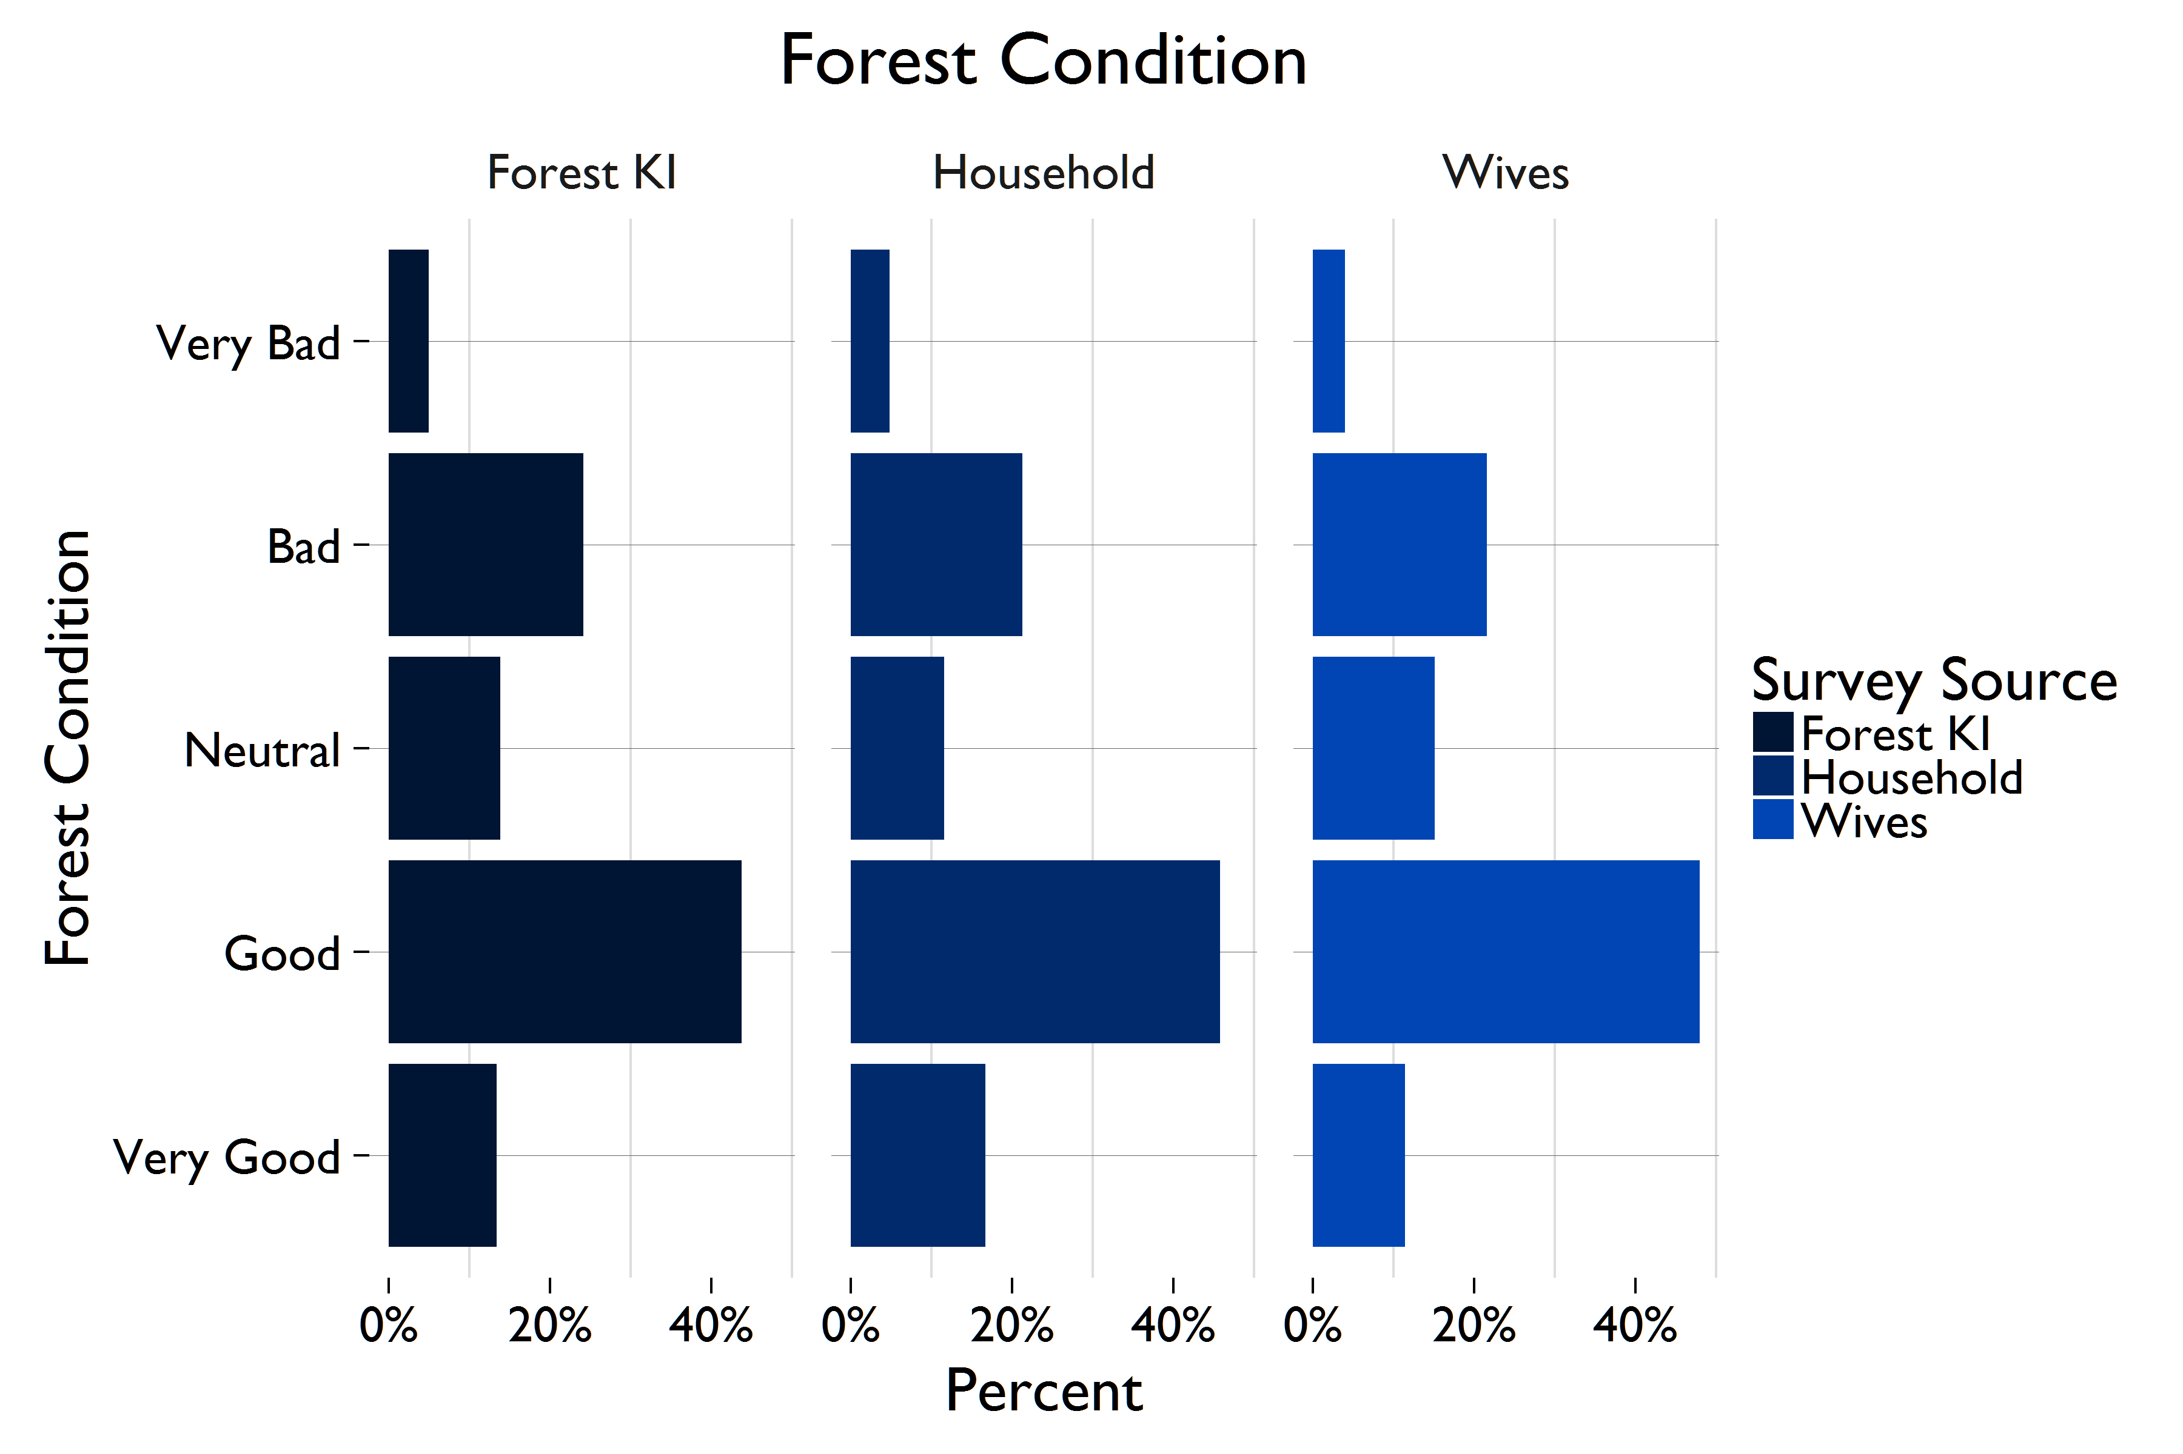
Figure 3.1—PERCEIVED Forest Condition according to respondent Type
Qualitative analysis complements household and wives survey findings, further revealing perceptions of worsening forest conditions. When asked to describe the changes in forests and wooded areas in comparison to three years ago, FGD participants often describe decreases in forest area and forest cover, a theme highlighted by youth in Mambwe who describe, “Because even these trees we are cutting in the past they were found nearby, but now you have to walk a distance for you to find a good tree for building house, they have finished the ones which were near…Compared to three years ago it is very bare.”
The household results also highlight a decrease in forest condition across the categories of forest thickness (49%, 1987), area (46%, 1845), and availability of products (45%, 1790). These perceptions are consistent across Forest Key Informants and wives and remain consistent when respondents are asked about changes in forest area and forest density.
The perception of changes to wildlife over the last three years were mixed. A sizeable proportion of Forest Key Informants reported the number of wildlife in their forest had decreased slightly (16%) or significantly (26%). However, many also reported their wildlife populations had stayed the same (25%) or increased (20%). Reports of new animals seen were very low (5.7%).
Table 3.1 illustrates the most common reasons households give for perceived decrease in forest area, primarily small-scale clearing for agriculture ad charcoal production. Qualitative findings echo these results. The clearing of forestland for agriculture is a main driver of deforestation discussed throughout the FGDs. This theme was most evident in Lundazi, where the most commonly mentioned reason for deforestation was the clearing of forest for small-scale farming. This theme was also evident in Nyimba, where youth explained, “After many years of cultivating the same land. You see a change. So you move and prepare new land…We just observe that the fertility of the land has reduced…The change is definitely there. As we cut the trees to open new fields and make charcoal, the forest areas reduce. You now find forest further away from here.”
Table 3.1— REASONS FOR PERCIEVED DECREASE IN FOREST AREA
 | N (%)
Small-scale clearing for agriculture | 1199 (65%)
Charcoal production | 565 (30%)
Timber harvesting | 358 (19%)
Poor harvesting practices | 364 (20%)

In Mambwe District, a seemingly recent increase in population was often noted as the key driver of deforestation. For example, women in Mambwe said, “The forest area has reduced because a lot of people have opened settlements. They come from Katete looking for farming land. Trees have declined extensively and the area of the forest has also reduced,” while youth in Mambwe District described, “The forest is reducing because the population is growing… yes the population has grown.”
In Mambwe and Nyimba Districts, one of the main drivers of deforestation mentioned throughout the qualitative data is charcoaling. Focus group participants in Lundazi do not specify charcoaling as an important source of livelihoods or a key driver of deforestation. Respondents observed and attributed changes in forest cover due to charcoaling. For example, youth in Nyimba explain, “We actually have little access this time since we have almost depleted the tree species in the forest. This is because charcoal burning is our main source of income and so we have depleted the forest.”
The high levels of charcoaling described in Nyimba highlight conflicting findings between household and focus group data. When households were asked if they used charcoal, an overwhelming 88% (3819) of households replied ‘No’. This statistic is nearly identical across female-headed household and districts. Yet in Nyimba, charcoaling activities are commonly mentioned in the qualitative findings and said to be main source of income and driver of deforestation in most villages. This discrepancy is likely due to the fact that charcoal extraction for marketing (outside subsistence use) is not legal without appropriate permits, as well as a tendency for FGDs to exaggerate the pervasiveness of charcoaling at the village level in a way that does not match individual household experiences.

4.0 FINDINGS—FOREST LIVELIHOODS & DEPENDENCE

Despite recognizing worsening forest condition, forest degradation is not ranked as the largest challenge to the majority of households or communities, and forest resources are not prioritized as highly as other assets for community development.
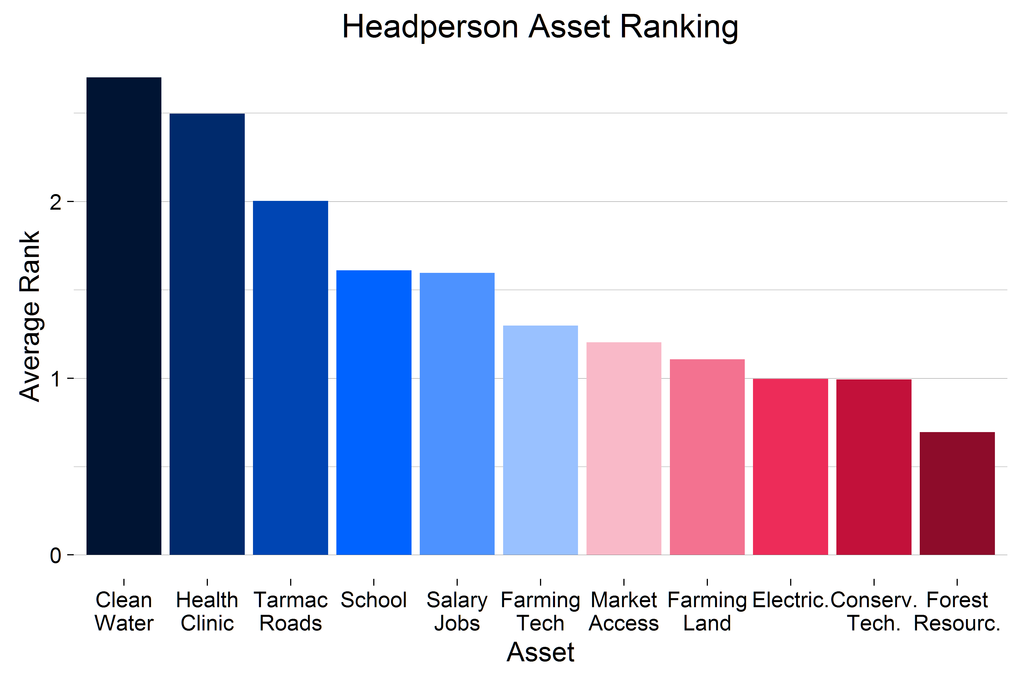
Respondents were asked to rank the five most important assets for community development from a list that included, among other things, forest resources, clean water, jobs, school, and agricultural land. The findings are similar across households, headmen, and wives. Only 25% (68) of headmen include forest resources among the top five most important assets, and only 15% (39) included forests resources in the top three. The assets most commonly included in the top five were health clinic (80%, 217), clean water (75%, 204), and tarmac roads (64%, 175). 54% (98) of headmen included conservation farming and eco-friendly charcoaling in their top 5 important assets. The average rank of all assets by headperson on a scale of 0-5 is displayed below in Figure 4.1.
Figure 4.1—Importance of various assets according to Headpersons

For household respondents, forest resources were the lowest ranked asset of all eleven assets—only .94 (sd=1.53) on average, on a scale of 0-5. Similar to headpersons, the assets ranked as the most important for community development are health clinic (3.12, sd=1.99), clean water (2.42, sd=2.01), and paved roads (2.28, sd=1.87). Figure 4.2 below illustrates the average ranking of assets for the household survey. Nevertheless, 34% (1480) of households report that forest resources are one of the top five important things for community development. Resembling the household and headperson distributions,
Two-fifths (1,741) of households and 37% (307) of wives included conservation farming (farming tech) and eco-charcoaling practices (conserve. tech) that protect the environment in the top five most important assets.
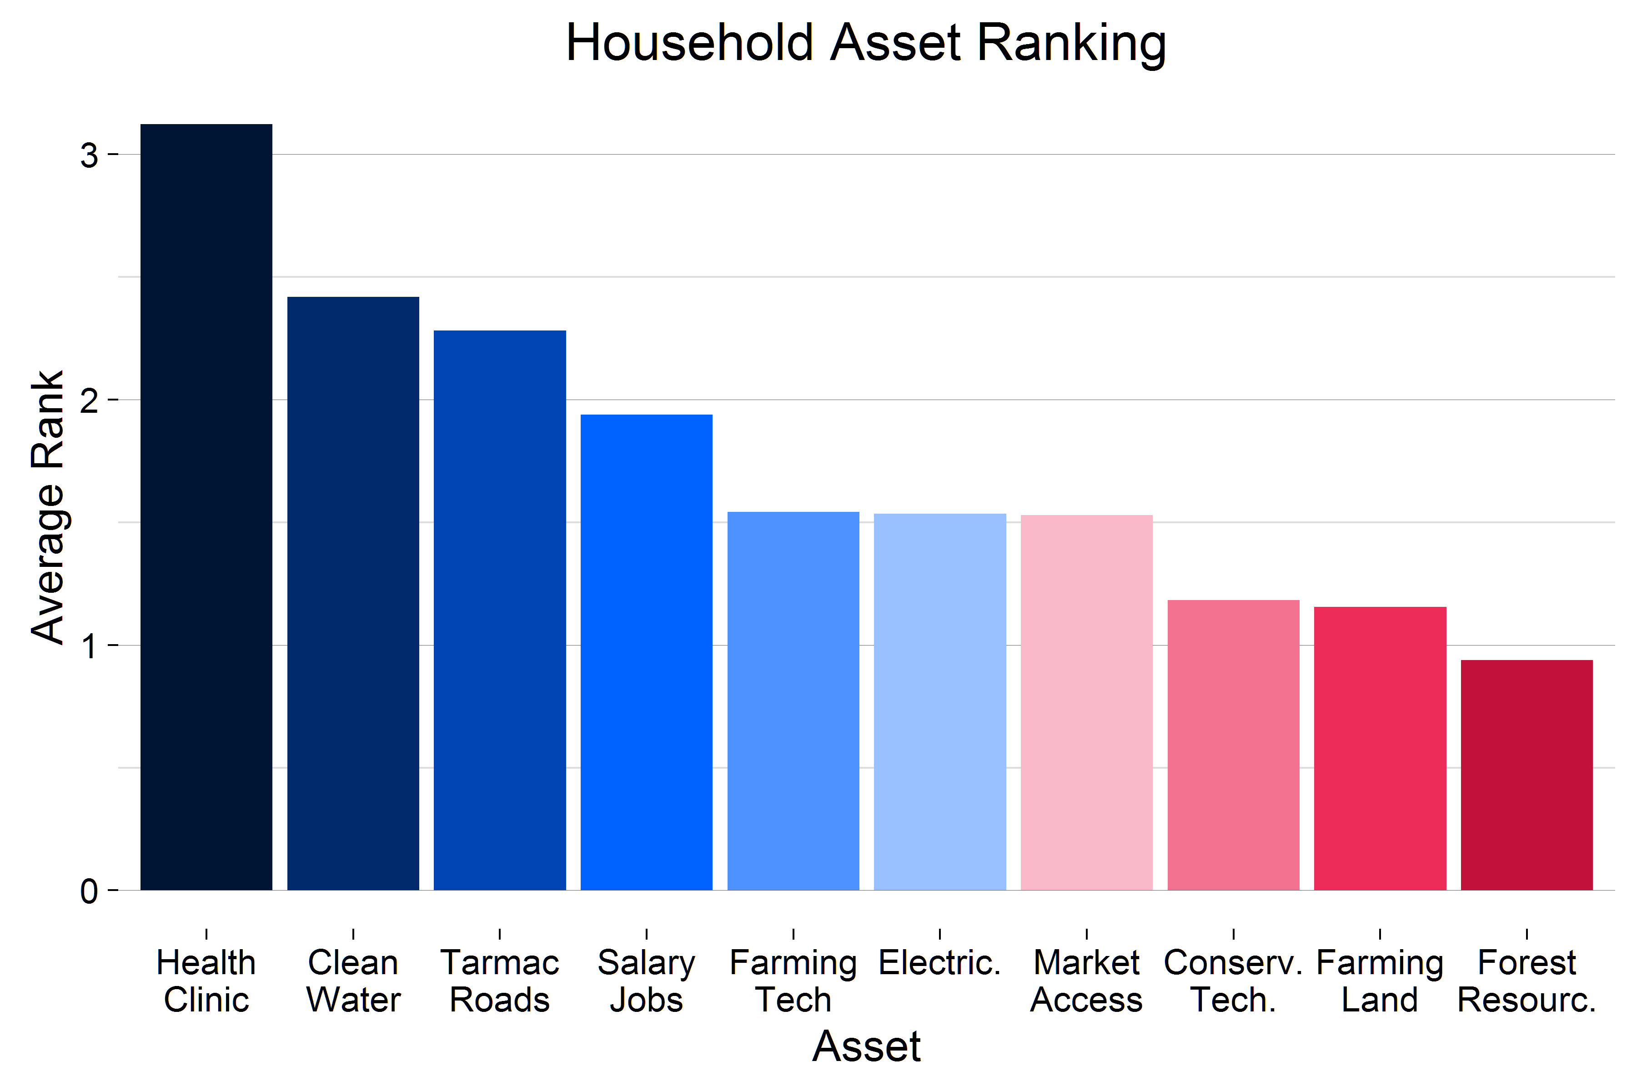
Figure 4.2—Importance of various assets according to HOUSEHOLDS
On a scale from 1 to 5, with 5 being the biggest problem, and 1 being the smallest problem, respondents were asked to rank various development problems that affected their community or household; a ‘0’ response indicates that the category is not considered a top five problem for ranking. Nearly 60% (160) of headmen said that forest degradation was not a top five problem facing their community’s development. Similarly, 59% (2573) of households did not identify forest degradation as a top five problem for their households. In contrast, 35% (1504) of household respondents rank rainfall patterns as the biggest challenge to their household, and 31% (1333) cited poor yields.

Although forest degradation is not ranked as the largest challenge to the majority of households or communities, there is important variation across the sample. A tenth (25) of village leaders and 11% (457) of household respondents rank it as the largest problem facing their village or household.

FOREST LIVELIHOODS & DEPENDENCE
Forest livelihoods and dependence also vary across households. Approximately 15% (655) of households in the sample are not dependent on the forest for consumption or income benefits; however, 84% (3468) depend on the forest for consumption and 19% (847) depend on the forest for income.

INCOME
Among households with access to forests, 23% (811) collect at least one forest product for income. Seven percent (332) collect more than one product. There are important differences between how various groups utilize the forest for income. Female-headed households (FHH) are less than half as likely as male-headed households to collect forest products for income, and 86% of all FHHs with access to forests (814) do not collect any forest products for income. Among wives with access to forests, 19% (108) collect at least one forest product for income. There are statistically significant differences across districts in the percentage of wives with access to forests that collect forest products for income. Twenty-two percent (87) of wives in Nyimba collect at least one forest product for income, compared to just 8% (18) in Mambwe and 4% (7) in Lundazi.
The most common forest products collected for income by households and wives are reported in Table 4.1. Selling timber is reportedly less common than expected (<1%, 14), as is the selling of wildlife, like bush meat (<1%, 10). However, as previously noted, these figures may underreport the number of households who engage in these activities. Many villages have rules about what type of timber can be harvested or sold, selling of bush meat is illegal, and selling of charcoal is only allowed with a government permit. As a result, households may be hesitant to report their participation. No households report selling honey or engaging in any beekeeping activities.
Table 4.1— Most common FOREST PRODUCTS COLLECTED FOR INCOME
 | N (%)
Household
Charcoal | 350 (8%)
Mushrooms | 227 (5%)
Fuel wood | 182 (4%)
Wives
Mushrooms | 227 (5%)
Charcoal | 26 (3%)
Fuel wood | 20 (2%)

Households who report selling forest products earn 960 ZMK on average annually (sd=1757). One percent of households earn income from other forest-related activities, which include patrolling forests, eco-tourism, and carbon payments. These activities earn slightly more income per year than selling forest products (1387 ZMK, sd=2076).
Female-headed households are 4% less likely than male-headed households to receive income from forest resources or activities, but there is no such difference between youth-headed or poor households. Poor households do, however, earn more money from selling forest products.

CONSUMPTION
Eighty-four percent (3682) of all households collect at least one forest product for consumption, and 43% (1921) collect more than one. More than 95% (3430) of households with access to forests collect at least one forest product for consumption purposes. Three-quarters of wives (603) collect at least one forest product for consumption, and 41% (256) collect more than one. The most common products collected for consumption by households and wives are detailed in Table 4.2. Unsurprisingly, fuel wood is by far the most common, followed distantly by materials used for building (wood for poles and fibers) and food sources. There are no significant differences across the treatment and control groups.
Table 4.2— Most common FOREST PRODUCTS COLLECTED FOR CONSUMPTION
 | N (%)
Household
Fuel wood | 3448 (80%)
Wood for poles | 915 (21%)
Mushrooms | 398 (9%)
Fibers | 389 (9%)
Wives
Fuel wood | 550 (91%)
Fruit, nuts, seeds, roots, and berries | 14 (2%)
Mushrooms | 14 (2%)

ENERGY USE AND FUEL CONSUMPTION
All households use wood for fuel, and wood—either fuel wood or scraps of wood—is the primary fuel used for cooking reported by households (97%, 4,205). Households spend an average of eight hours per week collecting fuel wood from forests and wooded areas around the village. However, with a standard deviation of approximately 64 hours, there is significant variation in this estimate across the sample. Wives report similar figures.
Twelve percent (521) of households use charcoal for fuel, and 2% (97) of households use charcoal as their primary cooking fuel. Charcoal is more difficult to produce and more expensive than fuel wood, so the small percentage of households using charcoal in rural areas is unsurprising. Charcoal use for cooking is far more common in urban areas of Zambia, and rural households that do produce charcoal prefer to sell the charcoal to urban areas than use it themselves.
Thirty-one percent of households (1,328) use some form of solar energy, primarily for lighting and for charging mobile phones. Female-headed households are 26% less likely to use solar than male-headed households, and youth households are 5% more likely than older households to have adopted solar.
Other sources of fuel or energy used within households are uncommon. Diesel, manure, electricity, gas, kerosene, and energy-efficient cook stoves are each used by less than 2% of households in the sample. The most common reasons households cite for not adapting these technologies is that they are unnecessary—either because alternative fuel sources like wood are plentiful, or because they use other sources, such as flashlights or candles, for light. In some instances, particularly for electricity and for energy-efficient cook stoves, the technology is not available in the community. Cultural reasons, health and safety concerns, and lack of knowledge are rarely given as reasons for not adopting a fuel source.

5.0 FINDINGS—CLIMATE CHANGE & ADAPTATION

Small-scale farmers in the study area are especially vulnerable to changes in climate and rainfall patterns. Agricultural practices rely heavily on tradition and take clues from consistent patterns in the environment, particularly the timing of the rains.
Zambian customary practices indicate that the rainy season begins on Independence Day (October 24). Farmers traditionally begin planting crops after the first light rains in October, which are typically followed quickly by heavy daily rains. However, recent years have seen a delay in heavy rains necessary for crop growth, and farmers who plant their crops based on the traditional calendar instead of observed rainfall patterns often experience crop failure before the rains begin.
Household respondents were asked a series of questions about climate related changes that they had observed in their community over the past three years. Table 5.1 below displays the household results. Reduced rainfall and changes in the timing of rainfall are the two most cited climate change observations.
Table 5.1—Household Respondents who have observed a given WEATHER related change IN THE PAST THREE YEARS
Observed Weather Change | N | %
Reduced rainfall | 3614 | 83%
Increased rainfall | 445 | 10%
Changes in seasonal rainfall patterns | 1936 | 44%
Changes in intensity/concentration of rainfall | 1209 | 28%
Drought | 1339 | 31%
Flooding | 202 | 5%
None | 119 | 3%

Qualitative findings also reveal widespread observance of changes in rainfall and seasonal patterns. When asked about changes in climate, nearly every group of FGD participants described differences in the timing and quantity of rain as compared to the past. This theme is illustrated through comments, such as “In the past it used to rain and the rains used to start early but that has changed. Now you plant in November and just after 2 months the rains go. That’s changing of the world” (Nyimba, Youth) and “The rains are not starting in their usual month...Sometimes it will only rain twice and stops until December. So the seeds you planted will not grow well. We see that there is change in the distribution of the rain.” (Mambwe, Women)
Changes in weather are perceived to be a larger threat to community health and development than forest degradation or deforestation. As discussed in Section 4 above, 21% (58) ranked rainfall changes as their biggest problem. Only poor crop yields were ranked as the most important problem more often than rainfall (32%, 88), and the two are closely linked. Almost 80% (214) of headmen ranked changes in rainfall as one of the top five problems facing their village, and 31% of headmen (85) ranked temperature changes as a top five challenge for their community.
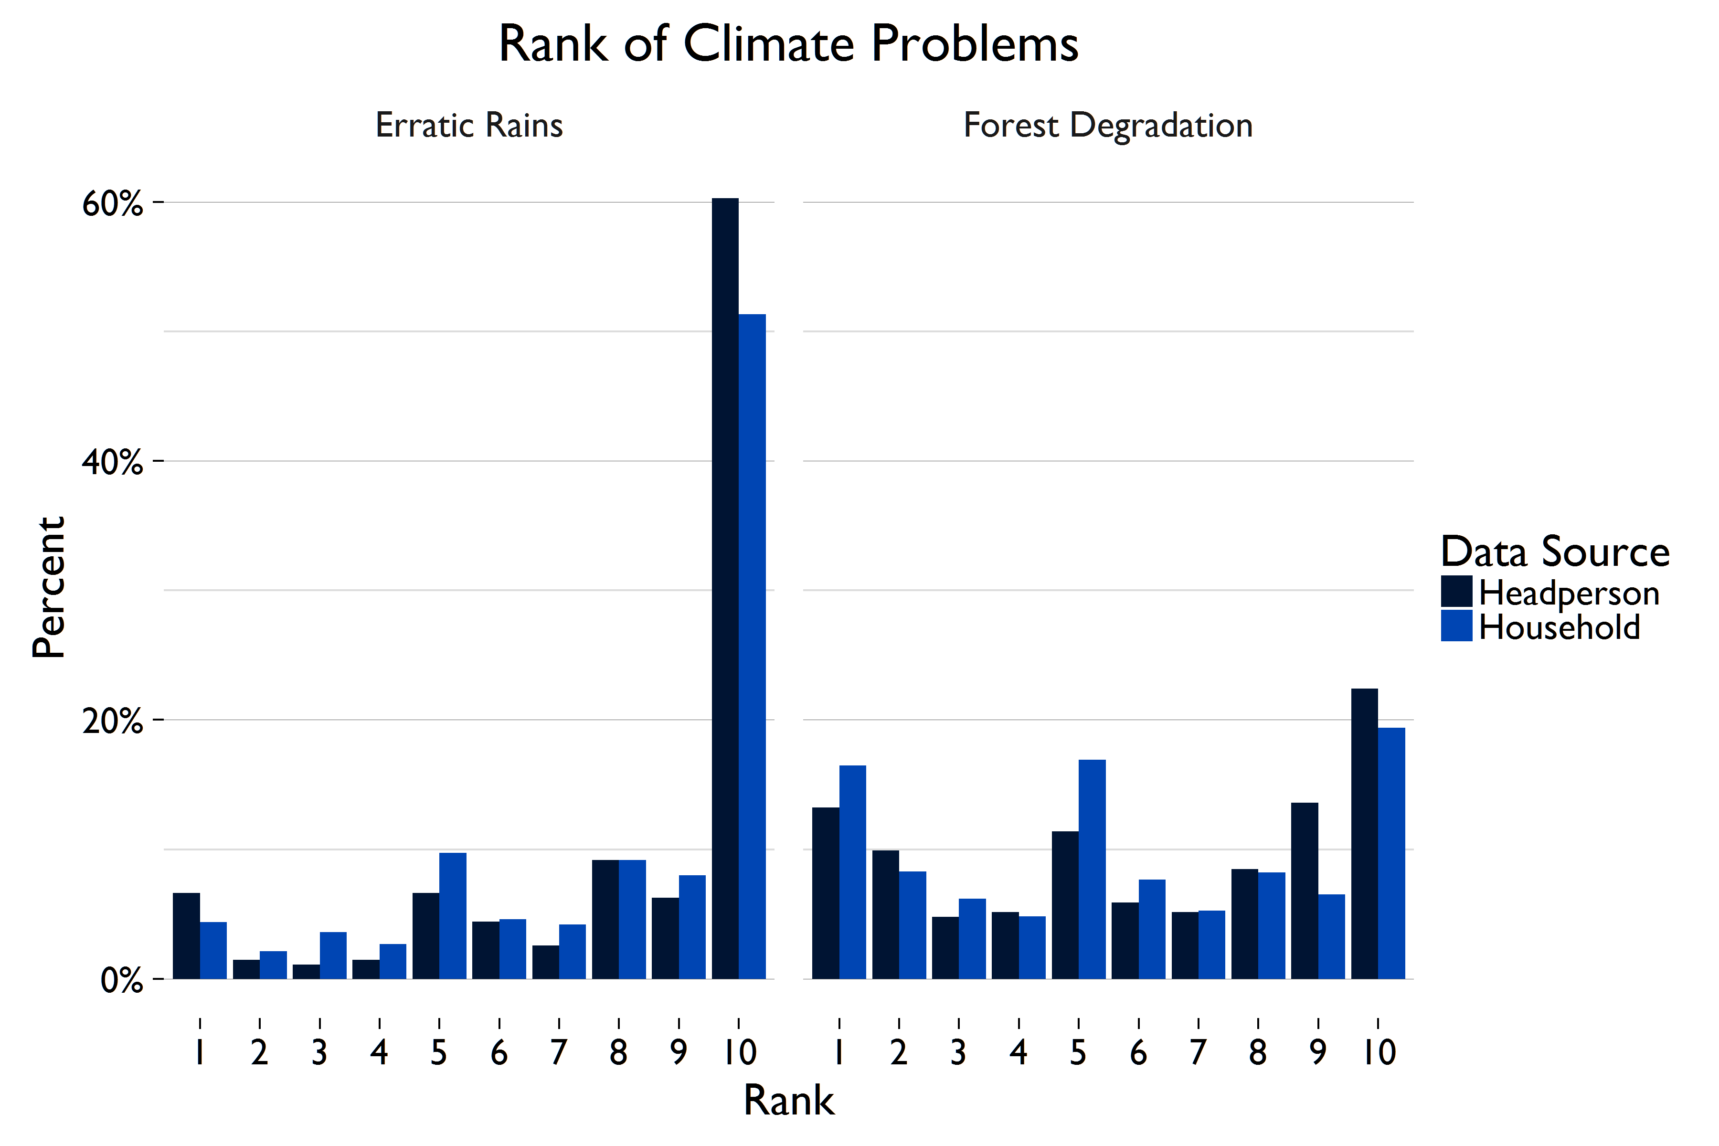
Figure 5.1 shows that 51% (2229) of household respondents and 60% (164) of headmen say that changes in rainfall patterns or temperature are the largest problem facing their village development. In comparison, 19% (842) of household respondents and 22% (61) of headmen said that deforestation or degradation is the biggest constraint to community development.
Figure 5.1—Comparison of Ranking of Climate Related Changes (10 is biggest problem, 1 is smallest problem)

IMPACT OF WEATHER-RELATED CHANGE
Results from the headman survey show that 65% of villages (176) were impacted by these irregular rainfall patterns in the past three years (Figure 5.1). In addition to the irregular timing of rainfall patterns, villages were also affected by both inadequate and excess rainfall. Forty-five percent (121) of villages reported experiencing a drought in the past three years, and 7% of villages (19) reported experiencing flooding. These results are displayed in Figure 5.2.

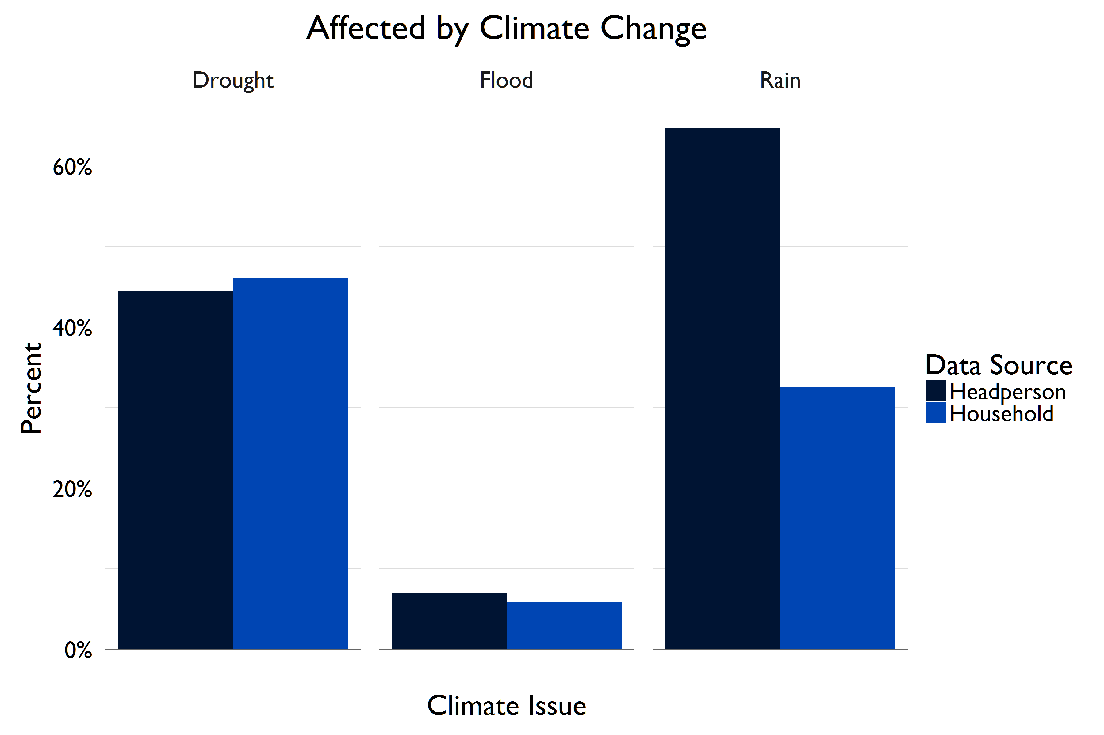
In the past three years, 63% (2690) of household respondents report having been affected by a perceived drought, flood, or erratic rains. It is important to note that these questions refer only to household’s perceptions of weather-related changes, not scientifically measured events. However, as Figure 5.2 highlights, the household results reflect an important divergence with the community results with regards to being affected by irregular rainfall patterns. The reasons for this are unclear but could relate to household interpretation of delayed rain as a drought. Droughts are the most common climate-related change experienced by households in the study area. Forty-six percent of households have experienced a drought. A third (1412) of households were affected by erratic rains, including rains that occur earlier or later than is typical, or rains that are lighter or heavier than usual. Floods are less common. Just 6% (254) of households have been affected by flooding, and households in the treatment group are just slightly more likely to experience a flood than those in the control group. Households are affected by climate events in a variety of ways, detailed in Table 5.2. The most common impacts are reduced crop yields (78%, 2047) and crop failure (78%, 1963).
Figure 5.2—Percentage of Respondents affected by WEATHER-Related ChangeS
Table 5.2— IMPACT OF CLIMATE EVENTS ON HOUSEHOLDS
 | N (%)
Reduced crop yields | 2047 (78%)
Crop failure | 1963 (78%)
Reduced food consumption | 1042 (45%)
Experienced hunger | 529 (25%)
Lost income | 312 (14%)
Experienced illness or death of humans | 84 (4%)
Experienced illness of death of livestock | 71 (3%)

FGDs help shed light on the effects of drought on food security, crop yields, and subsequent poverty. For example, women in Nyimba said, “Our farming has been affected, you find that when we just plant our seed, there would be no more rain…It is a big problem because it has brought poverty, food is not enough, fruit trees are no longer so fruitful and the grass we use for our houses is not growing well.”
Headmen do not seem to understand the importance of forests for mitigating climate change. Only 34% (93) of headmen believe that one of the top three non-resource benefits forests provide is climate regulation. Other common non-resource forest benefits listed in the top three include soil fertility (47%, 126) and land for grazing areas (28%, 77). Twenty-one percent (56) of headmen could name no non-resource benefits from forests at all.

RESPONSE TO CLIMATE IMPACTS
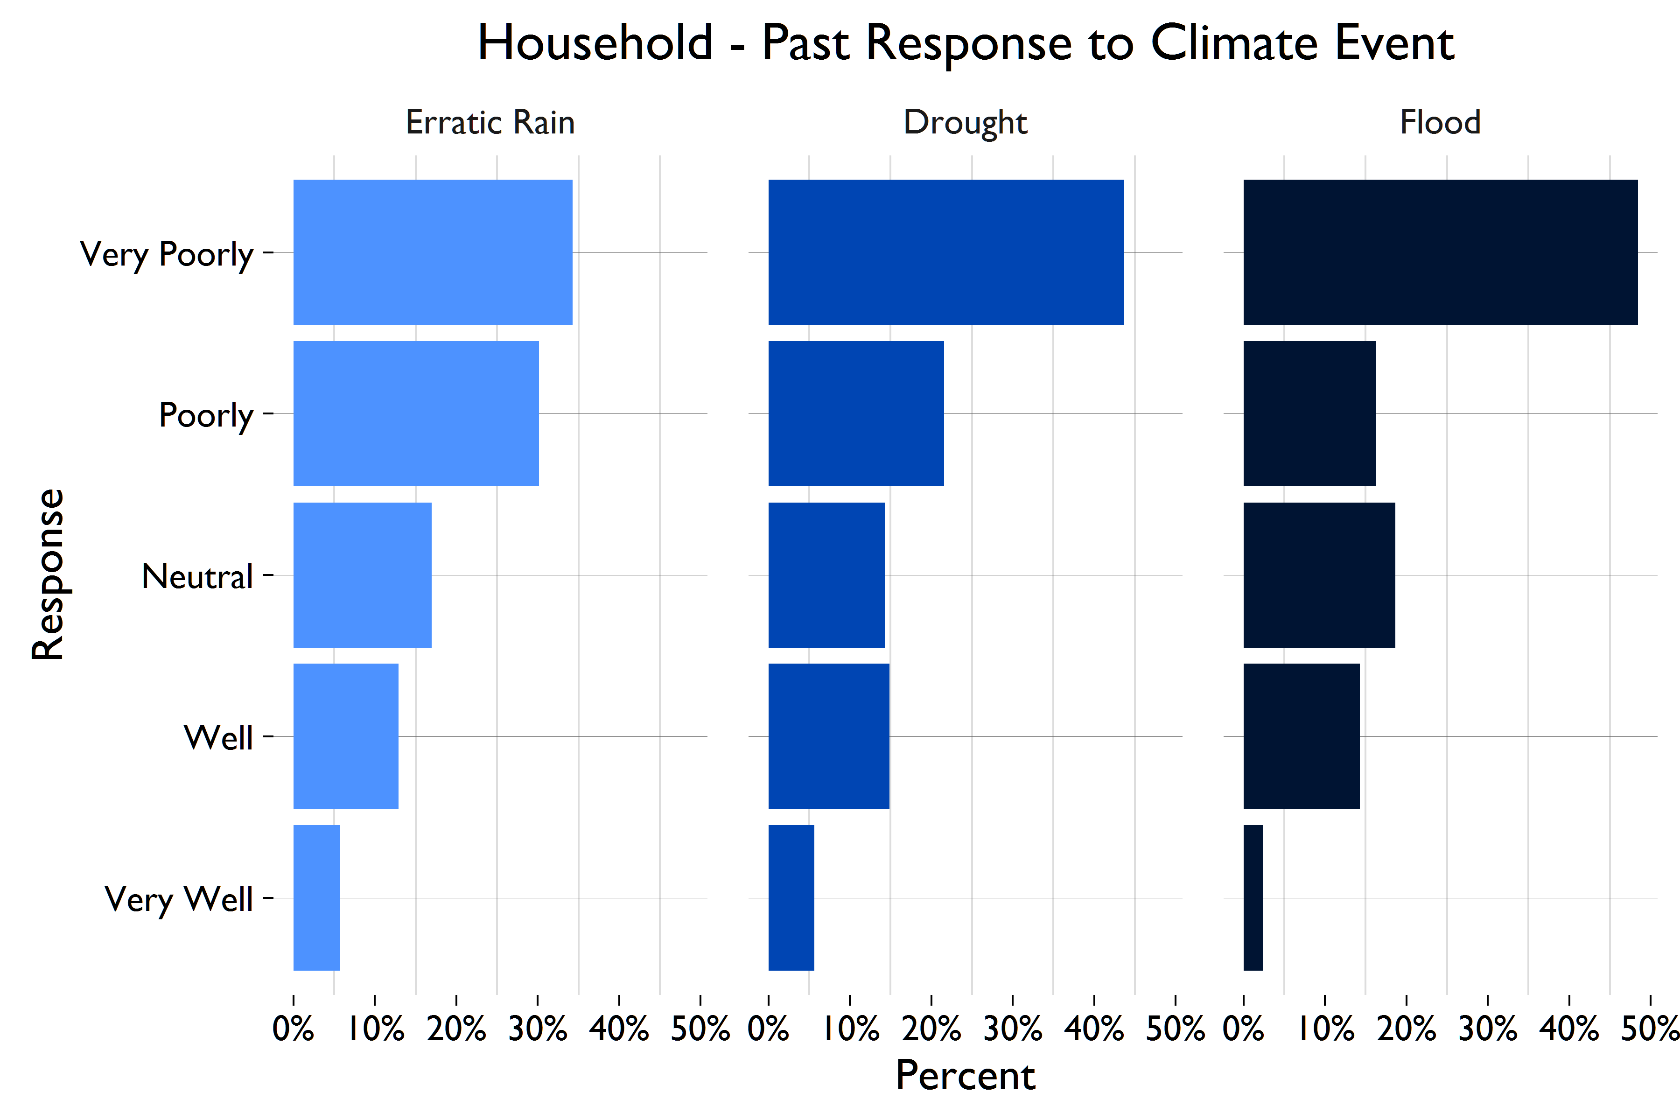
For each climate event, one-fifth or fewer households believe that they were able to respond well to the shock, an estimate that is consistent across sub groups. Figure 5.3 presents the findings below.
Figure 5.3—Household Ability to Cope with Climate IMPACTS

COPING STRATEGIES FOR WEATHER-RELATED EVENTS
Households employed a variety of strategies for coping with climate shocks, and similar coping strategies were reported across the household and wives’ survey. The most common adaptation to cope with droughts is to alter farming techniques (22%, 448), such as planting a different variety of crops, changing the time of year that planting occurs, or agroforestry. Ten percent of households (201) adapted new water technologies, such as building wells, irrigation, or crop water budgeting. Only 5% (108) of households implemented money-related coping strategies, including buying crop insurance, taking out a loan, or spending money on children’s education. Just under 20% (292) of households adjusted their farming strategies to cope with erratic rains, and 14% (43) made these changes in response to floods.
The most overwhelming response to weather-related changes was ‘to do nothing’. The majority of households made no changes in response to drought (61%, 1267), floods (60%, 188), or erratic rains (66%, 974). Lack of resources does not appear to be driving this inaction. Instead, it may be linked to lack of knowledge about possible adaptations, or a fatalistic cultural view that places the weather in the hands of God, as opposed to a force that can be influenced by people. Approximately two-thirds of households report that there were no additional changes that they wanted to make but were unable to. Of the remaining third, the most common adaptations people would like to make to better cope with droughts include farming techniques (13%, 267) and water-related infrastructure (13%, 260). Only 16% (228) of households would have liked to make farming-related adaptations to cope with erratic rains but could not, most often because of a lack of money.
Changes in weather do not appear to make households more dependent on the forests for either subsistence or for income. Only 5% (103) of households who were impacted by drought cope by collecting additional products for consumption from the forests, as do 4% (64) of households impacted by erratic rains. Only two households (<1%) turned to additional forest products to cope with floods. Less than 1% of households report producing charcoal as a mechanism for coping with these extreme weather shocks, though this figure may be underreported because of the illegality of selling charcoal without a permit.

6.0 FINDINGS—FOREST GOVERNANCES & CONFLICTS

The sample is predominately characterized by a customary tenure regime for forest use and access. Eighty-five percent (2119) of households note use and reliance on forests that are on communal land, whereas 13% (390) use forests on state land or GMAs. In this largely customary context, the headperson and chief are reported as being the primary rule and decision-makers regarding forest use and management.
Forest management decisions appear to be made primarily through customary channels. Almost 50% (2129) of household respondents said the headman is the most important decision-maker about the forests that the village uses, and 25% (1081) say that it is the Chief. Other important decision-makers are reported in Table 6.1. For example, among households that cleared land in the forest for farming in the past 3 years, permission was overwhelmingly requested from the headman (84%, 177), while 15% (27) asked for permission from the chief.
Table 6.1— most important DECISION-maker about forests
 | N (%)
Household
Headman | 2129 (49%)
Headman’s induna | 89 (2%)
Chief | 1081 (25%)
Chief’s induna | 50 (1%)
Council of elders | 8 (<1%)
Community resource board | 10 (<1%)
Village Land Committee | 11 (<1%)
Local government | 15 (<1%)
Department of Forestry | 194 (5%)
The village as a whole | 35 (1%)

According to the headman results, headmen are most likely to report they are the most important rule-maker about forestland management (40%, 110), but the Chief (or Induna, advisor) is the most important rule-maker for nearly an equal number of villages (39%, 106).
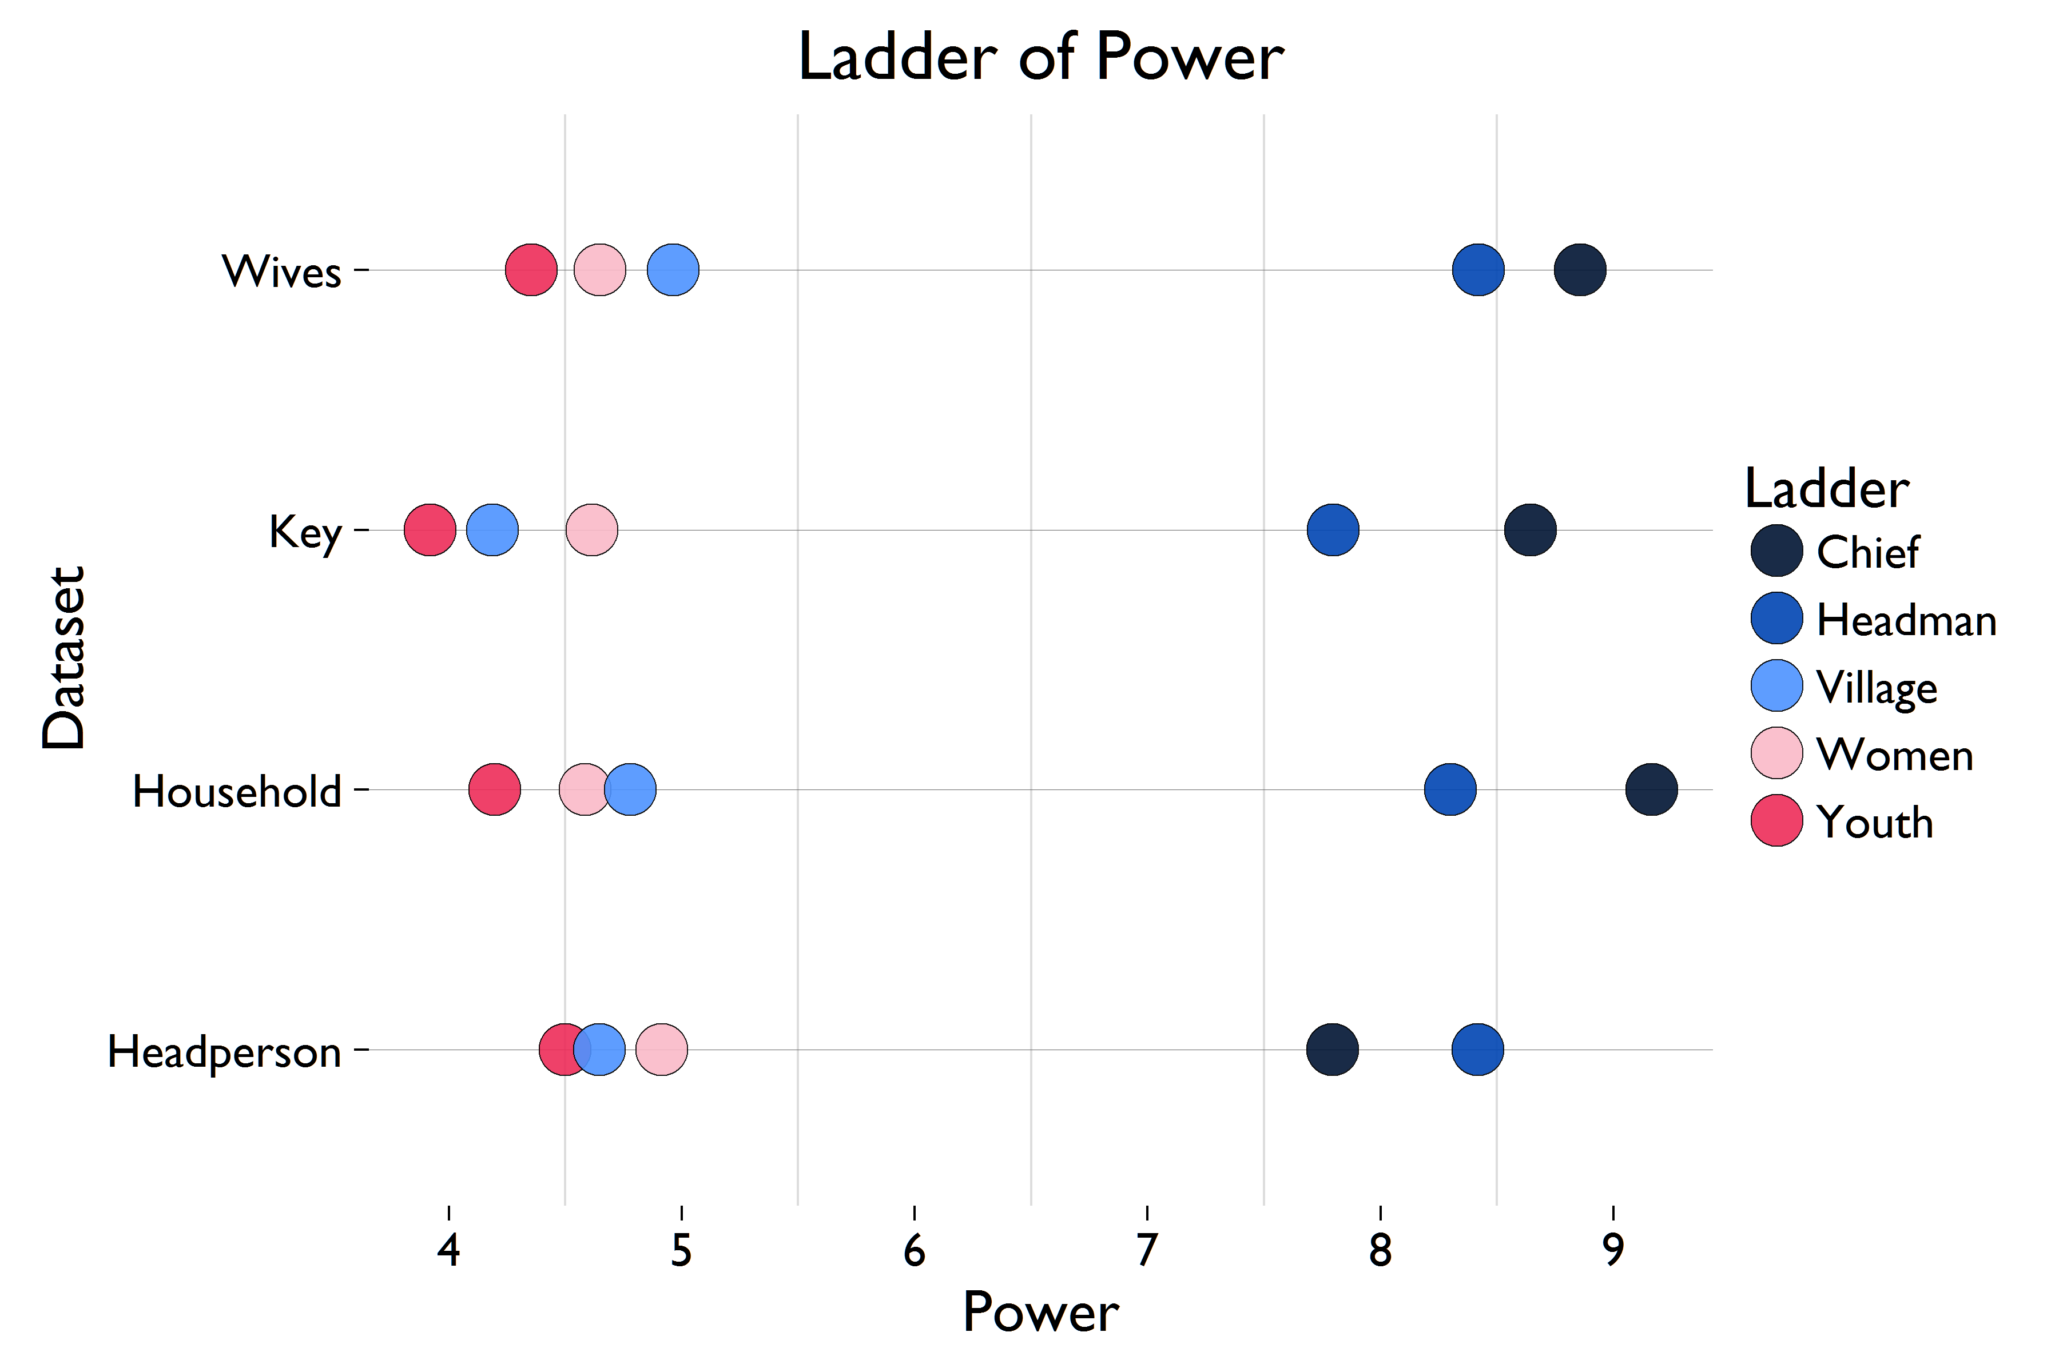
Government institutions, such as the District Forest Office (DFO) (9%, 24), Zambia Wildlife Authority (ZAWA) (2%, 6), and other ministries (2, 1%) are less likely to be cited as the primary rule-making bodies. Government institutions are also less likely to be viewed as the main decision-making body for forest management issues than customary institutions. The DFO is identified as the key decision-maker in 11% of villages (30), but no other government institutions appear to play a major role, despite the fact that ZAWA and the DFO are legally responsible for maintaining forests and GMAs in Zambia.
Figure 6.1—comparison of Ranking of perceived power held by each subgroup
(10 is the most powerful, 0 is the least powerful)

Respondents across all survey instruments were asked to rank customary leaders and various community sub-groups on a ‘ladder of power’ ranging from 1 to 10 for overall influence on decision-making regarding forest use and management. Figure 6.1 displays the findings across respondent categories. Household respondents overwhelmingly ranked the Chief at the top of the ladder (74%, 3215), and 23% (1010) said that the headman had significant decision-making influence. In contrast, the three groups at the bottom of the ladder—indicating no say in decision-making—include youth (28%, 1236), the village as a whole (27%, 1167), and women (25%, 1100). While households ranked the Chief highest, headmen rank themselves as slightly more important than the chief. Community elders, though less important than the headman or chief, are ranked next, followed by the community as a whole, women, and youth.
Only 15% (664) of households reported that there had been a meeting held about forest use, management, or disputes in their village in the past year. Among those noting a meeting, 14% (96) said members of their household ‘never’ attended the meetings, and only a slightly higher percentage said that females in their household never attend (16%, 104). The three main reasons for lack of participation include (a) busy working or traveling (44%, 42), (b) not informed about the meeting (11%, 11), and (c) sick or tending to others (16%, 13).
21% (59) of villages note a process for addressing grievances about forest management issues. The most common grievance mechanisms are to complain to the headman, or to complain to the chief through the chief’s induna or the headman. In some communities, a complaint can be registered with a village committee. If the complaint requires the involvement of ZAWA or the DFO, all actions must take place through the chief.
Community resource management institutions are rare. 20 villages (7%) have a forest resource board, and it is a key decision-maker about forest resources in 5% of communities. There is weak evidence of local organization around forest user groups. Only 12 (4%) villages in the study sample have any forest user groups. Correspondingly, 8% (349) households reported the presence of a forest management group in their community that organizes activities related to forest management, such as firefighting, patrolling, tree planting, etc. Thirty-seven percent (129) of those reporting the presence of a user group said that a member of their household was involved in the group.
Only 4% (195) of households report the presence of a local village institution or committee for forest management. Sixty-one percent (118) said that women are involved in the group’s leadership, and 66% (129) report that women are members. Of these, 88 households (45%) stated that they had a household member participate in a local election for leadership positions, and 45% also reported that a woman in the household had participated in the election. Moreover, despite a small opportunity for participation in local governance, 64% (2801) of household respondents and 59% (478) of wives said that they had sufficient knowledge about forest management to participate in rule development.

RULES
Eighty-one percent (218) of villages have at least one rule about common forest management topics. Table 6.2 shows the prevalence of forest management rules by type, as reported by headmen. Reported compliance across all types of rules is incredibly high in the headman survey. Clearing forestland for agriculture has the highest rate of compliance, at 98% (50). Rules about collecting wood for fuel have the lowest compliance (78%, 7). All other rules have compliance rates of 90% or higher.
Sixty-five percent (177) of headmen believe that village rules about forests or wooded areas are enforced effectively, and 79% of headmen (216) believe that forest rules are fair. Nearly half (131) of headmen believe that penalties about forest use and access are enforced equally across different groups. A quarter (59) of headmen who believe penalties are enforced unequally believe that youth in the community experience harsher penalties than other groups.
Table 6.2— PRESENCE OF VILLAGE RULES ABOUT FOREST MANAGEMENT
 | N (%)
Setting fires for clearing fields | 126 (67%)
Cutting trees for timber | 134 (49%)
Setting fires for hunting | 130 (48%)
Cutting trees for charcoal | 126 (46%)
Grazing livestock | 64 (24%)
Clearing land for agriculture | 51 (19%)
Collecting fuel wood | 9 (3%)

The qualitative findings paint a different picture about rule enforcement and compliance. Focus group participants commonly explain that while rules exist that restrict forest activities, specifically charcoaling and the cutting of trees, the rules are not effectively enforced and therefore rarely followed. According to respondents, the lack of alternative income generating activities plays a major role in why rules are not followed. While focus group participants often state that they understand the rules exist to curb deforestation, they are dependent on forests as an important source of livelihoods and therefore view restrictions as unfair and as a source of hardship.
Youth in Nyimba District illustrate this common theme and describe, “These rules are not fair because we are not in employment and all what we need is in the forest, now from the time they introduced these rules like restricting hunting, that is why poverty is increasing.” Another participant in the same group goes on, “In my own view, these rules are fair. The problem is that they have toughened the rules for hunting and logging. It is the government that comes to stop us from doing these activities but there is nothing they give us so that we get helped in the end. Now like this, there is nothing to do, and in the end, we go in the forest to collect whatever we want. What makes us go in the forest is not our fault, it is because of poverty.”
The presence and fear of ZAWA, the national wildlife regulating authority responsible for creating, monitoring, and enforcing rules in GMAs, suggests that the rules that restrict hunting are strictly enforced and therefore village members comply. However, the rules that restrict the hunting of wildlife are also commonly mentioned as unfair. When youth in Nyimba District were asked if they believe the penalties associated with breaking rules that restrict hunting are fair, respondents said “The penalties are not fair. The reason people are hunting wildlife is because of the problems we face here. And the rules are not fair. How can they prefer wildlife over a human being? If an animal destroys someone’s house or kills someone we are not supposed to do anything.”
Forest rules are also commonly cited as “coming from the government,” and focus group participants express frustrations surrounding the perception that those who make the rules are not affected by them. For example, youth in Nyimba District describe, “We even said earlier before that these decisions are not good because they are not fair to us. This is because those who impose these rules on us don’t suffer and so they don’t know anything, they get paid every month, they are working and everything is going on well with them. Then for us, we don’t do anything, our lives depends on the forest.”

CONFLICT
Conflicts about forest land, access, or resources are extremely rare in the study area, as reported by household respondents and displayed in Figure 6.2 below. Ninety-eight percent (4246) of household respondents report that their households had not experienced any disputes over use or access to a forest in the past 12 months. One hundred and nineteen disputes were reported in the study area; only 5 respondents reported that the dispute had led to violence or destruction of property. Among the 96 households involved in a forest related dispute, 56% (54) were boundary disputes, 23% (22) involved cutting trees, and 10% (10) were related to ownership over trees in the forest. When conflicts do occur, they are most likely to be internal, as opposed to with other villages or with outsiders.

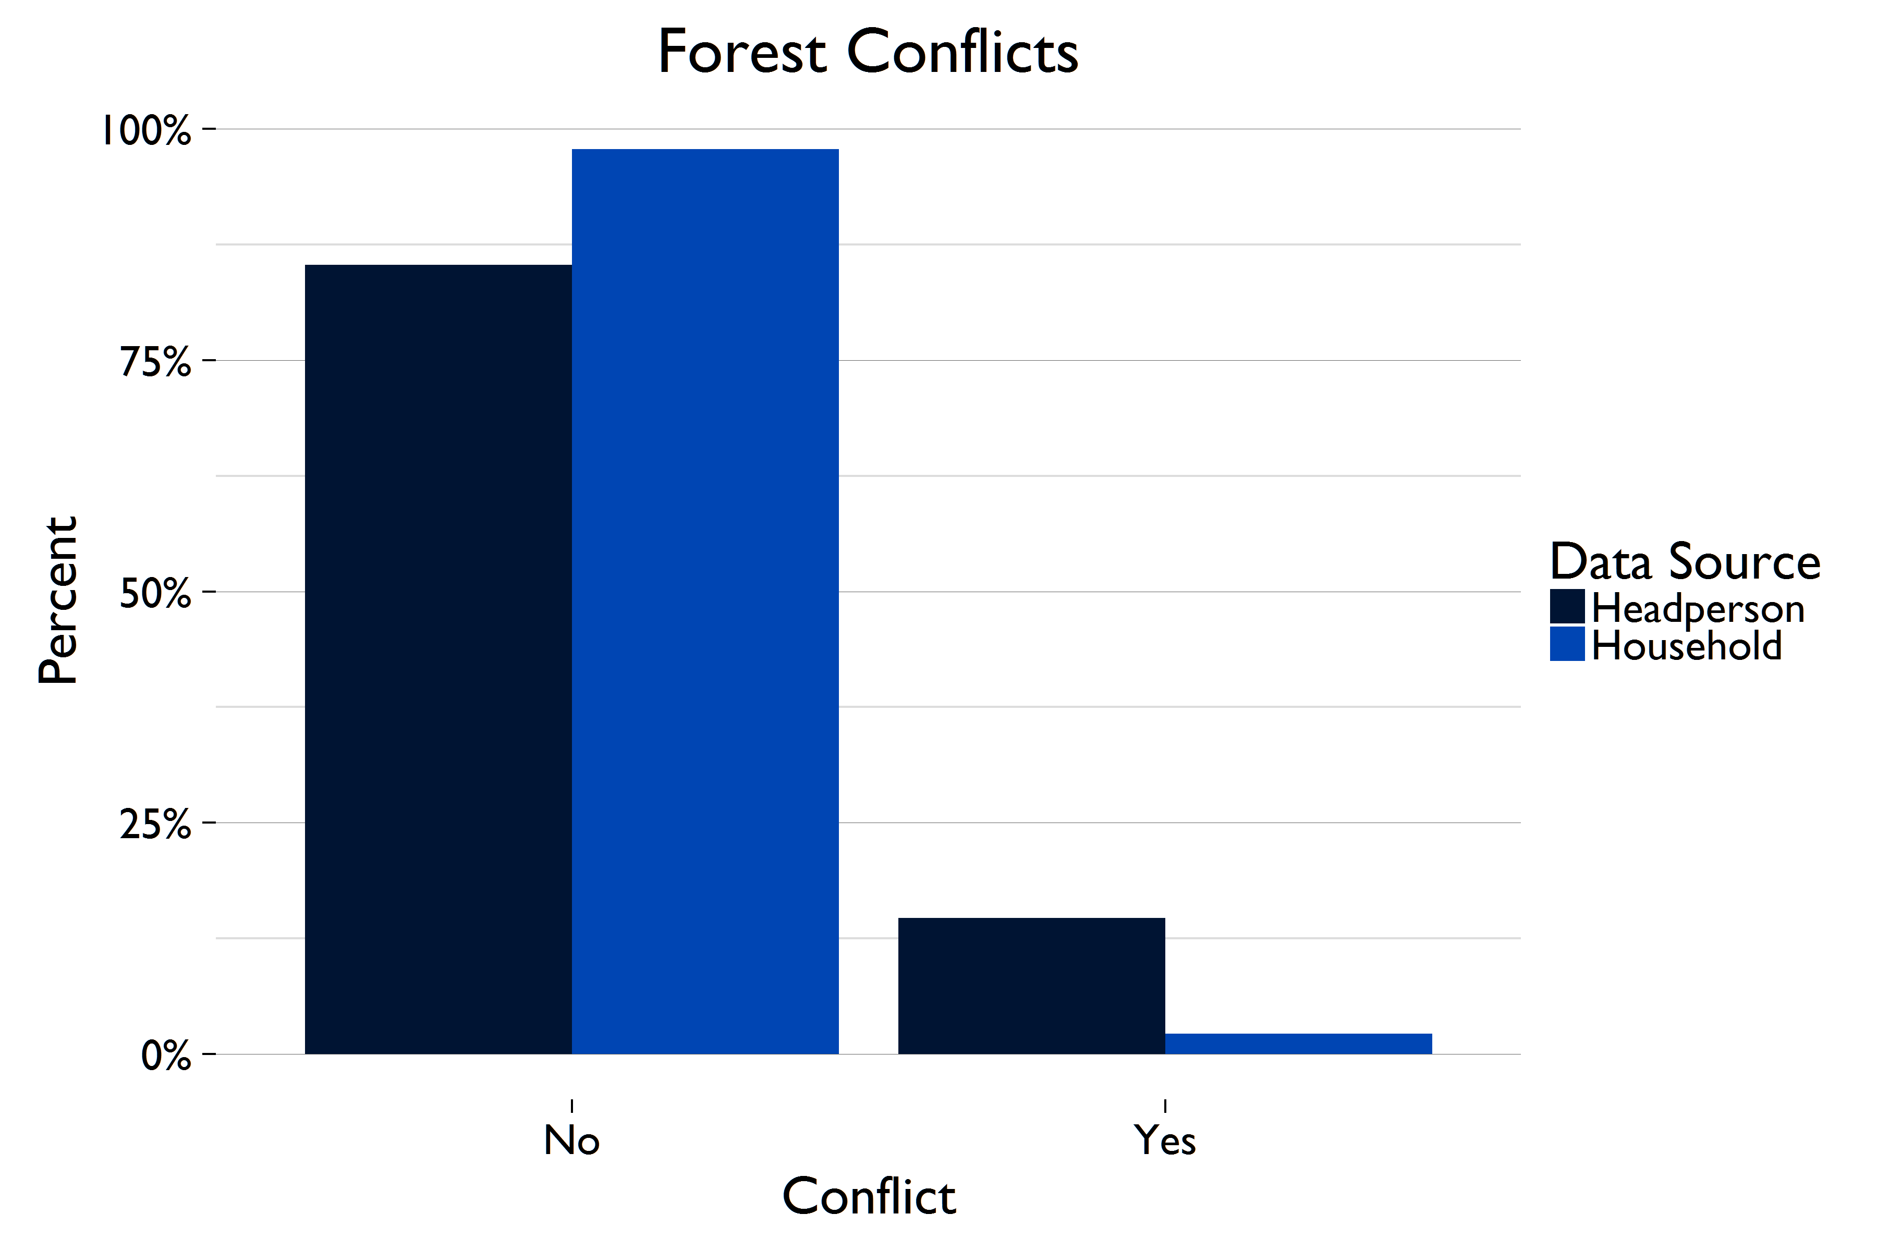
Figure 6.2—occurrence of conflicts
The headman findings indicate a greater degree of conflict. Compared to the 98% estimate for households, 84% (229) of headmen report the absence of internal village disputes over forestland or resources. Of the 16% of headmen who did experience an internal village conflict, the most common type of dispute was about boundaries (9%, 25), followed by disputes about grazing livestock in forest ground (3%, 7), and cutting down trees in forests (1%, 4). Headmen are most likely to report that they are the most important person for resolving internal village forest disputes. Of the 43 headmen who experienced internal conflicts, 65% (26) say they are the most important actor, followed by the chief (15%, 6) and the headman’s induna (5%, 2). Government institutions, such as ZAWA or the DFO, play little role.
Conflicts between villages over forestland or resources are even rarer than conflicts between households. Only 16 headmen (7%) experienced any forest-related conflicts between their village and another village. The most common type of conflict is about cutting trees from the forests and/or charcoaling (3%, 6), followed by grazing livestock in forests (1%, 2) and inheritance-related disputes (1%, 2). Similar to inter-village disputes, headmen are most likely to claim they are the most important actor for resolving conflicts (40%, 14), though 34% (12) say the chief is most important. Government institutions play a limited role.
7% (16) of headmen experienced a conflict with an outside actor, including the government, investors, or miners. The most common source of conflict with outsiders is about hunting and fishing (3%, 6) and cutting trees in the forest (2%, 5). The chief is the most important actor for resolving conflicts with outsiders (40%, 12), followed by the headperson (27%, 8).
The household findings on dispute resolution corroborate the information gathered from the headperson surveys. According to household respondents, the primary person/institution where disputes are taken for resolution include the headperson (41%, 48) and chief (25%, 29). Most respondents (75%, 57) stated that their dispute was resolved by the first place where it was taken, and a little over half of respondents said that it took one week or less to resolve. Among those that had a dispute resolved, the overwhelming majority were ‘very satisfied’ (39%) or ‘satisfied’ (49%) with the outcome.
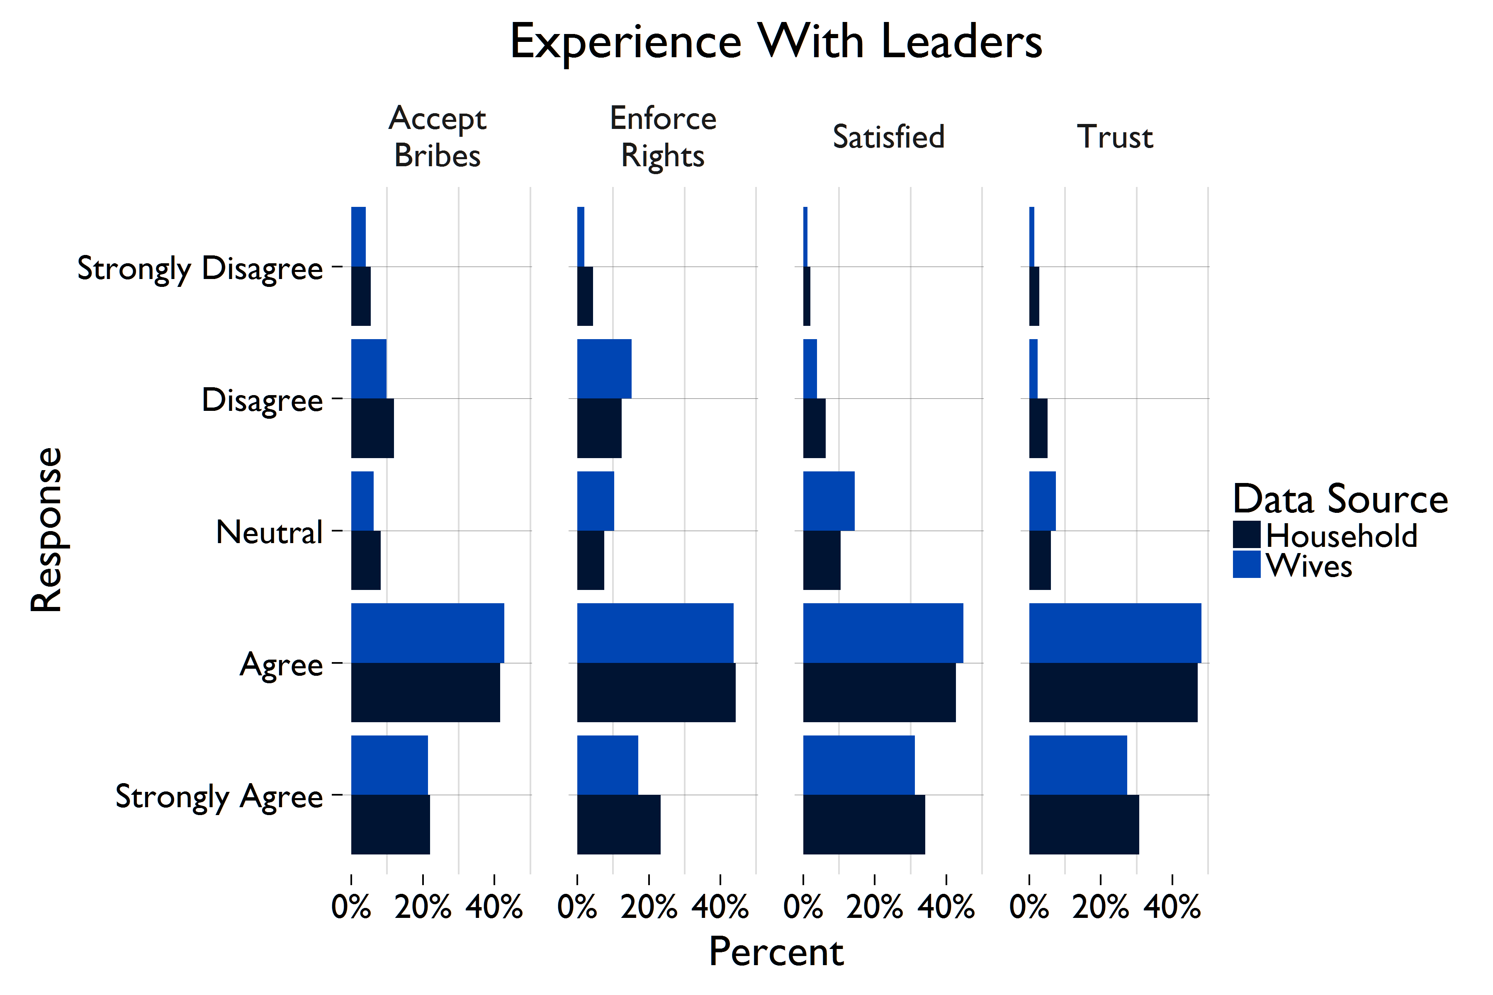
Overall, 77% (3336) of heads of household are satisfied with the way that local leaders resolve conflicts and govern forest resources, as well as rules that govern forest access and use. These assessments generally range from 72-78% depending on questions about fairness of use, fairness of access, transparency, etc. The exception to this includes corruption and enforcement. Here results indicate that 36% of respondents expressed the likelihood of bribe taking by local leaders, and 32% did not feel confident that local leaders would enforce their rights during forest related disputes. The wives’ results reveal a similar distribution. However, across the governance series, wives generally score 2-6% lower than head of households. The largest discrepancy, 6%, is for an indicator on whether or not the rules are well-known; 72% of household heads ‘agree’ or ‘strongly agree’ with this statement compared to 66% of wives. Figure 6.3 shows how much respondents agreed or didn't with various characteristics of local leaders.
Figure 6.3—experience with Local leaders

7.0 FINDINGS—FOREST TENURE & ACCESS

FOREST TENURE & ACCESS
According to Zambia law, all land is owned by the State and cannot be purchased or owned by individuals. Instead, land in Zambia is divided into two types: state (or titled) land, and customary land. State land is under the control of the Ministry of Lands, Natural Resources, and Environmental Protection (MLNREP), and can be titled and rented to individuals or companies via one of four types of leases, ranging in length from 10 years to 99 years. State land accounts for approximately 15% of all land in Zambia.
The majority of land in Zambia is customary land. Nearly all people in the study area access land for individual use through customary land management systems (99.6%, 268).
This land is administered under customary law, and applies to individual plots, forestland, common grazing land, and common village land. Land is held by individuals, families, clans, or communities generation to generation and without a temporal limitation. There are no documents securing customary land use rights.
The baseline findings suggest that most people feel fairly secure in their rights to forests, although a significant minority report perceived tenure insecurity. Head of households, wives and headpersons appear relatively confident that their village’s forested land will not be encroached upon by any party in the next three years. Over half of all headmen believe that encroaching upon their customary forestland in the next three years by investors, government, the chief, or elites, is “impossible.”
Nevertheless, as Figure 7.1 depicts, a significant minority of headperson and households express concern about unauthorized expropriation of forestland used by their villages. There are similar levels of concern about unauthorized expropriation across households and headpersons. The category of greatest concern to respondents is that the chief will reallocate or take land without village consultation—this is expressed by 25% (1091) of households and 25% (69) of headmen. Next, the government is seen as a source of unauthorized reallocation by 24% (1065) of households and 24% (67) headpersons. Approximately 16-17% of households express concern over potential land confiscation by elites and investors, whereas these figures are 13% and 21% for headmen, respectively.

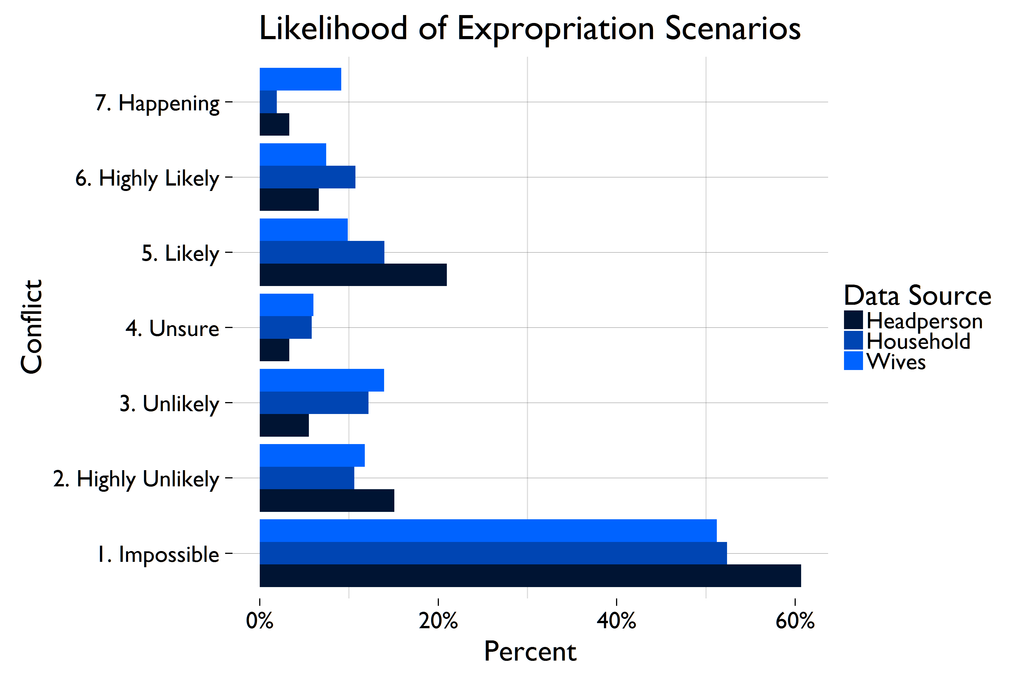
Figure 7.1—Likelihood of expropriation of forest land in the next 3 years
Similar trends regarding expropriation concerns are reflected in the wives’ responses, as displayed above in Figure 7.1. Wives reported the greatest threat of encroachment from the chief or government. Twenty-two percent (153) of wives believe that the chief encroaching on their forestland is likely, highly likely, or currently happening. A slightly higher percentage of wives, (23%, 163) believe encroachment by the government is likely. Investors and elites are seen as the lowest risk with 13% (94) of wives expressing concern for investors and 11% (82) expressing concern for elites.
Access and restrictions
The level of unauthorized expropriation concern may be explained—in part—by actual experiences with expropriation and loss of land in the past. Out of 272 villages in the sample, 5% (13) said that customary land under forest cover had been sold or leased to someone from outside the village in the past five years, and 24% (66) report no longer being able to access forests the village used to access. Thirty-nine percent (50) of headmen in the Nyimba district reported losing access to a forest that their village use to have access to, compared to 15%(11) headmen in Mambwe and 7% in Lundazi. The most common reason for losing access is that the forest was sold or leased (63%, 42). In 21% (14) of cases, either the government or forestry department told communities they could no longer access the forest, and in an additional 9% (6) of cases, the chief told the community the land could not be accessed.
Qualitative findings reveal that the reallocation of forestland to lodge owners is commonly mentioned as a cause of lost forest access, particularly in Nyimba District. For example, a group of women in Nyimba explained, “It has reduced, because part of the forest had been sold to some investors to develop the area. We don’t move anyhow to get what you need. An investor has built a lodge in the same area and we don’t trespass. Once found you will be charged.”
According to the headperson findings, the biggest impact on villages due to loss of forest access is economic. Thirty-eight percent (25) of villages that lost access to a customary forest experienced failed business or lost access to forest resources that were important for income. An additional 14% (9) lost agricultural land, and another 14% (9) lost access to resources for consumption.
Among households with access to forests, 15% (611) reported new restrictions within the past year that had affected their ability to access or ease of accessing or collecting resources from forests, while the majority (84%, 3331) noted no new restrictions. Eleven percent (430) reported that a permit is needed to collect forest products. As displayed in Figure 7.2 below, these response trends are similar for wives. The overwhelming majority (96%) of household respondents stated that restrictions were related to conservation and rules to prevent harvesting forest products. Forty-four percent (269) of those noting restrictions said that they were imposed by the District Forest Office, 35% (111) named the Chief, 18% (111) said the Headperson and a smaller percentage of respondents said that the restrictions were imposed by ZAWA (12%, 71), private owners (5%, 32) or a company (6%, 38).
Analysis of the qualitative data highlights a number of important themes relevant to forest access. The qualitative findings reveal two main reasons for lost or reduced access to forests including: 1) new or increased government restrictions on the use of forest resources (including wild game): 2) the sale of community forest land to lodge owners.
Regarding increased forest restrictions by the government, a group of youth in Mambwe said, “Accessibility of the forest has reduced because the other side is ran by the forest department and you cannot collect even firewood, no cutting trees, no hunting from there.… accessibility has reduced…it has reduced because we have not been allowed to go in and cut trees.” Focus group participants also point to the presence of the ZAWA in forests. Fear and perceptions of violence by ZAWA, particularly expressed by female FGD participants, is associated with negative impacts on access to forest resources. For example, women in Nyimba said, “Men can get up to say…oh let me go and look for rattan from the forest. When he is found he is apprehended to say he is a poacher hunting for animals, yes. They are arrested sometimes… if they are not lucky when they go there, they are killed right there in the forest …even when that person did not go there to kill for animals, he just went there to look for rattan or to collect bamboos. So even going there, they do not have full rights. They go with fear.”

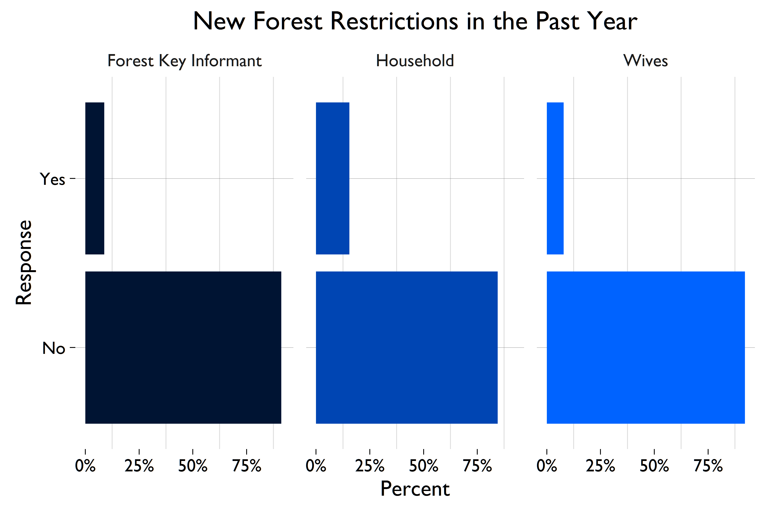
Figure 7.2—New forest Restrictions in the Past Year
Qualitative findings suggest the reallocation of forestland to lodge owners is a common cause of lost access, particularly in Nyimba District. The following quotes illustrate reduced access due to the reallocation of forestland to lodge owners, and highlight the specific forest resources, such as medicine, insects and grass, which can no longer be collected as a result of the reallocation of the land and subsequent restrictions. “(R): In the beginning, our parents used to go into the forest up to Nyimba river, now the land where the river is has been sold to lodge owners. So the freedom to collect things like insects or grass is not there or even just mlaza (rope material gotten from tree barks) is not allowed, ah…ah! The place has been sold…the forest land has been sold, part of it is no longer ours.”
“(R): It [access to forests] has reduced, because part of the forest had been sold to some investors to develop the area. We don’t move anyhow to get what you need. An investor has built a lodge in the same area and we don’t trespass. Once found you will be charged.…Access to the forest has reduced, because of a lodge you may need some medicine from the forest but you could find that the tree that contain the value of medicine is between the boundaries of that area which was sold, and it’s difficult to pass through and get the medicine.”
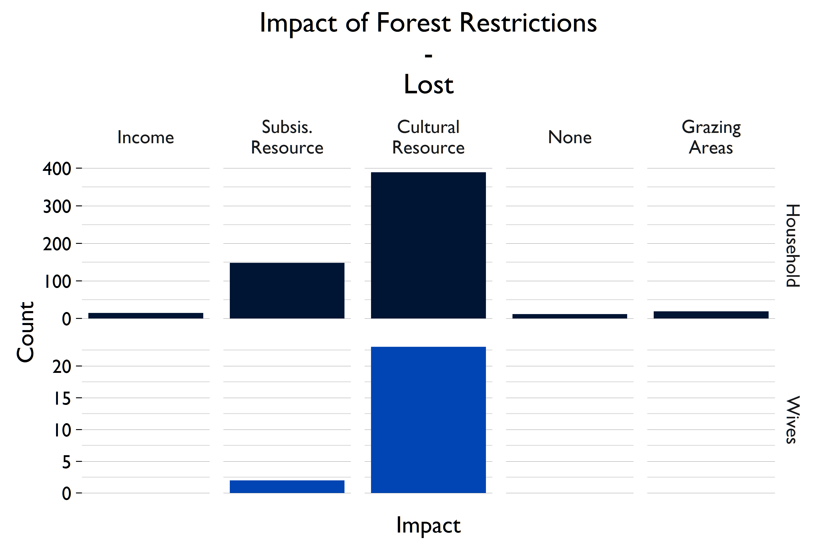
Interestingly, as shown in Figure 7.3, 65% (388) of those noting restrictions said that the restriction on access had no impact on their household. A quarter (147) said that they had lost subsistence resources and 16% (97) reported a loss of income.
Figure 7.3—Impact of forest restriction: Loss of Benefit

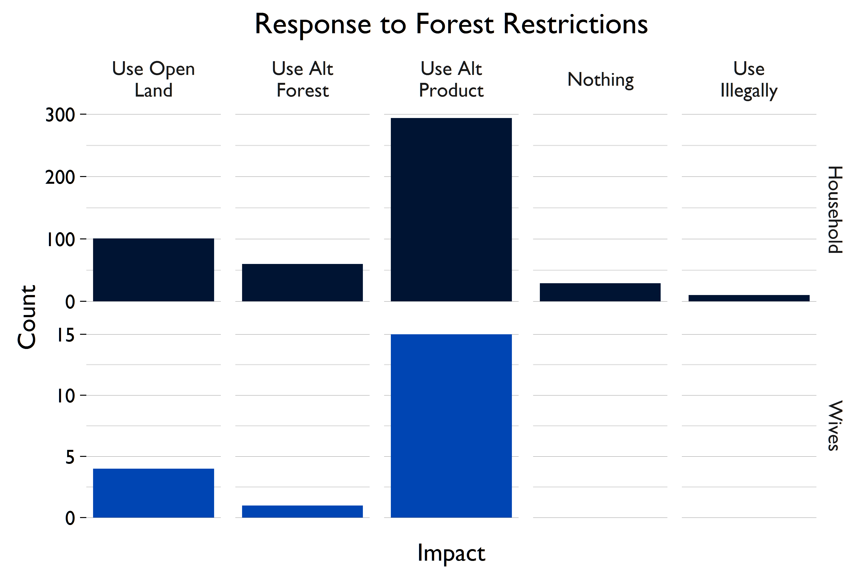
Shown in figure 7.4, correspondingly, 48% (292) reported that their household has responded to the restrictions by going without. Twenty-one percent (127) say that they have shifted to harvesting forest products from open lands and 15% (92) have begun to rely on alternative products.
Figure 7.4—Response to forest restriction
The qualitative results tell a different story. FGDs indicate that recent and changing restrictions on forests from government (including ZAWA) and lodge owners have depleted forest-based income generating activities, with hunger mentioned often as an everyday and serious issue. Many focus group participants explain that they are no longer allowed to hunt for meat or fish as a result of restrictions. When asked about forest restrictions and the effect of lost access on livelihoods, a group of women in Mwambe explained, “If they don’t allow us access to the forest then we will die of hunger…Access to the forest cannot reduce, because life goes on, for access to reduce it would mean there is no more life, because many, especially in the village depend on trees.”
Another theme present in the qualitative findings is that forest restrictions are leading to an increased dependence on farm yields for food and income, (while crops are simultaneously failing due to drought and erratic rain patterns) For example, when asked one group of men was asked why they identified their fields as the most important spaces to their village, they explained,
“(Respondents): Because we are not employed, when we sale maize that is how we get some money so that we can buy clothes, and for school going children. We get our money from cultivating bananas, maize (Interviewer): Is there not something else you can do apart from cultivation, economically? (Respondents): There is nothing else, When we burn charcoal, you get arrested…When we burn charcoal we get arrested, we try to hunt for game we are arrested, you log timber you are arrested, so the only thing we do is cultivation.”
The following quotes illustrate the lack of income-generating alternatives available to support livelihoods in the survey area. When asked about the areas in the village that help generate income, a group of men participating in a mapping exercise in Nyimba said, “There is nothing. We just suffer. When we sell charcoal that is when benefit… Charcoal and firewood we put by the roadside, when you sell, you generate income to help at home and sending children to school. As there are no companies where we can get employed and get paid every month end … there is nothing. There are children that need to be educated through charcoal.” Women in Nyimba posited, “If they stop us from burning [making] charcoal how are we going to survive?”
Finally, focus group participants often mention the lack of income-alternatives to harvesting forest resources and farming, and commonly express a desire for salaried jobs to reduce dependence on forests and farming. For example, youth in Mambwe said, “The government needs to create more jobs so that people can stop depending on the forest products.” When asked what about potential benefits that they believe would make people in their village willing to change the practice of charcoaling, women in Nyimba also stated a desire for salaried jobs to reduce dependence on forests and said, “I think jobs would help, because if we are working and getting paid we cannot be charcoaling.” This suggests that CFP’s intended livelihood activities could fill an important gap in these communities.

8.0 GENDER-SPECIFIC FINDINGS

The CFP evaluation is one of the first ERC designs that use a wife-specific survey to learn about gender differences in perceptions and outcomes. The wife survey asked a subset of questions from the household survey to 820 wives of household survey respondents, primarily focused on women’s perceptions of forest and weather conditions, and women’s access and use of forested land. Gender differences and similarities across major outcomes of interest are detailed in this section.

Forest condition
Wives are 15% less likely to access at least one forest than the household as a whole (32%, 255). However, there was no difference between wives’ perceptions of the conditions or changes in condition of the forest and the perceptions of the household respondent. Similar to both the household respondent and the forest key informant, over half of wives believed their forests to be in “good” or “very good” condition, and a similar number of wives report that the condition of the forest has worsened in the past three years.

Forest livelihoods and dependence
Wives also have similar opinions about the importance of forest assets and environmentally-friendly technologies in their village as respondents to the household and headman surveys. Thirty-eight percent (305) of wives included conservation-friendly technologies like eco-charcoaling and conservation farming as one of the top five village assets, compared to 40% of households (1741). Wives were slightly less likely than household respondents to include forest resources amongst the top five important assets (28%, 220) but the difference is not statistically significant. Like the household and headman survey respondents, the most important village assets for wives were clean water, health clinic, and paved roads, detailed in Figure 8.1

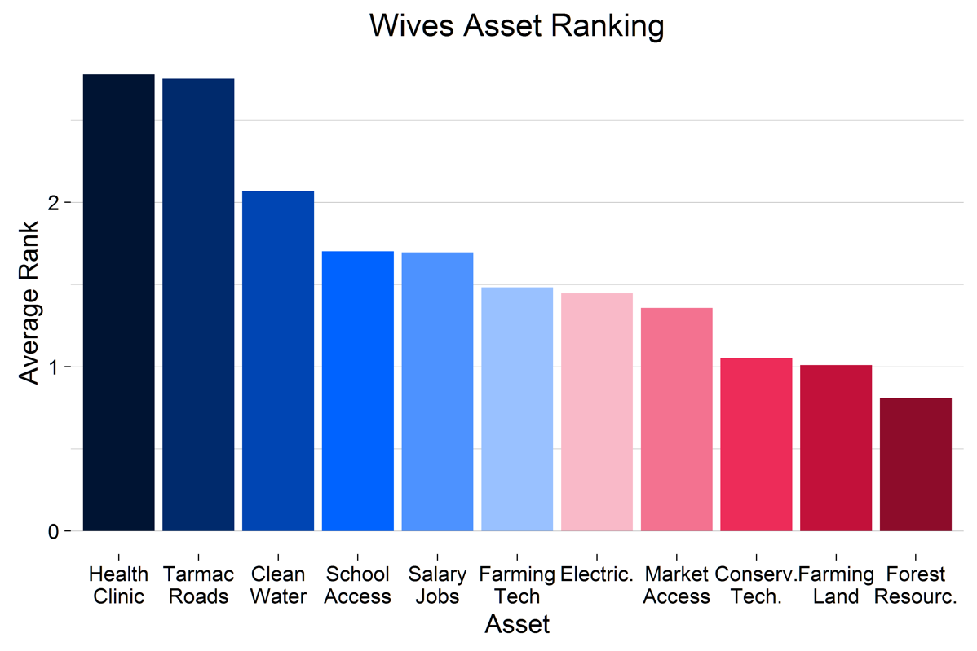
Figure 8.1—Importance of various assets according to WIVES
Unsurprisingly, wives’ reliance on forest products consumption is very similar to household reliance as a whole, including the types of products collected and the likelihood of collecting forest products for either income or consumption. However, there are significant differences between how female-headed households and male-headed households utilize forest products. Female-headed households (FHH) are less than half as likely as male-headed households to collect forest products for income, and 86% of all FHHs with access to forests (814) do not collect any forest products for income. Among wives with access to forests, 19% (108) collect at least one forest product for income. There are statistically significant differences across districts in the percentage of wives with access to forests that collect forest products for income. Twenty-two percent (87) of wives in Nyimba collect at least one forest product for income, compared to just 8% (18) in Mambwe and 4% (7) in Lundazi.

Weather changes and adaptation
Households as a whole, wives and female-headed households have similar views about the threat of weather-related changes and forest degradation to their community’s health and development. Changes in rainfall were ranked among the top five problems more than any other issue (87%, 702). Almost 40% (317) of wives included forest degradation as one of the top five problems facing their village, exactly the same proportion as household survey respondents (1780). There are also no significant differences in perceptions of the presence of erratic rains, floods, or droughts between wives and household respondents, or in respondent’s ability to cope with these changes in weather. Wives and female-headed households also do not report being more likely to rely on forest products to cope with crop failures than household respondents generally.

Forest governance and conflicts
Wives survey respondents were asked to rank the perceived power of various community members about making forest-related decisions, including the chief, headman, women, and youth on a scale of 0 (least powerful) to 10 (most powerful). Their perceptions line up with those of the household, headman, and forest key respondent. Wives rank the chief at the very top of the ladder (9.0), followed by headmen (8.3), elders (5.5), the village as a whole (4.9), women (4.6), and at lowest level, youth (3.8). This ranking order is identical to the household respondents, and suggests that other survey instruments accurately assess the role of women in forest-decision making.
Wives are just as unlikely to report conflicts about access or use of a forest are just as household respondents—in both surveys, less than 2% of respondents report a single conflict in the past year. Wives are also equally likely to be satisfied with their community leaders, and to believe that rules about forest use and access are fair. Wives do appear to be less likely to attend community meetings about land use or management than households generally, detailed in Table 8.1. A quarter of wives (24%, 21) never attend these meetings, compared to 14% (96) of households generally. The household survey also indicates that women from their households never attend meetings in 16% (104) of households, a lower figure than reported by wives personally. The main reasons for not attending are lack of interest (29%, 6) and busy working or traveling (29%, 6).
Table 8.1— Frequency that wives attend meetings about village land management
 | N (%)
Always or nearly every time | 28 (32%)
Often | 15 (17%)
A few times | 2 (2%)
Once or twice | 21 (23%)
Never | 22 (25)

Forest tenure and access
Head of households, wives and headpersons appear relatively confident that their village’s forested land will not be encroached upon by any party in the next three years. However, nearly 10% of wives believe that forested land is presently happening, more than double the percent of household respondents who believe this to be true. Wives reported the greatest threat of encroachment from the chief or government. Twenty-two percent (153) of wives believe that the chief encroaching upon their forestland is likely, highly likely, or currently happening. A slightly higher percentage of wives, (23%, 163) believe encroachment by the government is likely. Investors and elites are seen as the lowest risk with 13% (94) of wives expressing concern for investors and 11% (82) expressing concern for elites.
Despite higher levels of reported land encroachment, wives are slightly less likely to report new restrictions in forest access in the past year (13%, 73) than households generally. It is possible women are less aware of new restrictions because women have greater freedom then men to enter restricted areas, either accidently or with intent, without being accused of hunting or poaching by ZAWA, reducing the stakes of violating the rules. Wives who report new restrictions are most likely to be impacted by losing access to subsistence resources (18%, 13) or income sources (15%, 11), leading them to substitute other products.

ANNEX I—CFP IE DESIGN REPORT

Please refer to the following link to view the Design Report for the CFP IE:
http://www.usaidlandtenure.net/sites/default/files/USAID_Land_Tenure_CFP_IE_Design_Report.pdf

ANNEX II—QUALITY CONTROL FORMS

On the following pages are the forms used for ensuring that enumerators were conducting surveys and doing so correctly. The first is a spot-check form used while a supervisor oversaw an interview. The second is an audit form used when a supervisor returned to a respondent to gather information and make sure that the enumerator really had interviewed the respondent.

Enumerator Spotcheck

Enumerator name: ________________________

Supervisor name: ________________________

Date: ________________________

1. Does the enumerator have all necessary materials?
Charged mobile device, tracking sheet, pen, notepad, backup paper survey, waterproof bag

Yes No

2. Did the enumerator properly conduct he informed consent process?

Yes No

3. Is the interview being conducted one-on-one in a private place?

Yes No

4. On a scale of 1 to 5, please rank the enumerator’s familiarity with the questionnaire and the ability to ask questions and probe correctly
Is the enumerator explaining questions properly? Are they probing when appropriate to get more detail? Are they recording answers in the correct categories?

1 2 3 4 5

5. On a scale of 1 to 5, please rank the enumerator’s ability to create a rapport with the respondent
Does the respondent appear comfortable? Is the enumerator dressed appropriately? Is the enumerator asking questions in a neutral way?

1 2 3 4 5

Comments

Enumerator Audit Form

Total Points: |  | V2
Auditor name: |  | Audit date:
Enumerator name: |  | Survey date:
Respondent name |  | Respondent ID
Contact information /landmarks/nicknames

Did the interview take place with the household head?
If not, reason it was not:

1. Was the interview conducted with the correct respondent?

Section B/C Household information | Audit answer | Original answer | Points
B10. Were you born in this village? | 0=No  1=Yes |  | (3)
B22. Is the village land that your household farms passed down from the wife's family or the husband's family? | 1=Wife’s family  2=Husband’s family  3=Land was purchased by or given to the household  97=Other, please specify  888=Don’t know |  | (3)
C.1 How many people live in your household? definition of a household: 'a group of people who live in the same homestead (which may consist of more than a single dwelling) and share food and other items bought from a common household budget. This includes people who are away temporarily.’ | (integer) |  | (3)

Section H: Climate Change | Audit answer | Original answer | Points
H2. In the past 3 years, have you observed any of the following changes in your village? | 1=Reduced rainfall  2=Increased rainfall  3=Changes in seasonal patterns (e.g. when rainy and dry seasons begin)  4=Changes in intensity/concentration of rainfall (e.g. all the rain falls in fewer days than before)  5=Drought  6=Flooding/landslides  97=Other, please specify |  | (2)
H7. On a scale from 1 to 10, with 1 being the smallest problem and 10 being the biggest problem, how big of a problem are changes in rainfall patterns and/or changes in temperature to development of your village? | (integer 1-10) |  | (1)
Section K - Farmland | Audit answer | Original answer | Points
K1. During this agricultural year (2014/2015), what is the total land area that your household owns? | Integer:  Unit  1=Lima  2=Acre  3=Hectare  4=Square meter  888=Don't know |  | (2)
K2. What is the total number of fields that your household owns? |  |  | (3)

The next questions apply only to the LARGEST FIELD
 | Audit answer | Original answer | Points
L11. What was the method by which this field was acquired by your household? |  |  | (2)
L4. During this last agricultural season (2014–2015), did your household farm this field, leave it fallow, or use it for pasture or some other non-agricultural use? | 1=Farmed this field  2=Left this field fallow  3=Left this field in improved fallow  4=Used this field as pasture/other non-agricultural use |  | (2)
M1. What is the tenure status of this field? | 1=State land  2=Former customary land converted to state land  3=Customary |  | (2)
M12. In the next 3 years, how likely do you think it is that the chief will give this field up for investment purposes? | 1=Impossible/would never happen  2=Highly unlikely  3=Unsure/I don't know  4=Likely  5=Very Likely  6=Happening right now  999=Prefer not to respond |  | (2)
M15. How many seasons could you let this field lie fallow without being worried about the field being reallocated to another household?  If they do not think it will ever be reallocated, enter 777 |  |  | (3)
Section M, continued (all fields) | Audit answer | Original answer | Points
M.18 Does anyone outside of your household make decisions about how you manage your fields? (For example, crops that you can plant or what to do with surplus crops)  If 0, skip to M20 |  |  | (2)
M.20 Thinking about disputes over the last 1 year across all of your fields, can you please tell me how many disputes your household has experienced about BOUNDARIES |  |  | (2)
M.20 Thinking about disputes over the last 1 year across all of your fields, can you please tell me how many disputes your household has experienced about TREE CUTTING/OWNERSHIP |  |  | (2)

SECTION N: FARMLAND GOVERNANCE | Audit answer | Original answer | Points
N2. In your village, what person or group is the most important decision maker about the farmlands that your village uses? | 1=Headman  2=Headman’s Induna  3=Chief  4= Chief’s Induna  5=Council of Elders  6=Village Land Committee  7=Local government  8=Department of agriculture/ extension officers  9=Most or all villagers together  10=a local or national NGO  97=Other, please specify |  | (2)
N4. In the past 12 months, were there any meetings held about land use, management, disputes or resolutions of disputes held in your village? | 0=No  1=Yes |  | (3)
Now I am going to read some statements about forest management in your village. Please tell me how much you agree or disagree.

N.14 I feel that rules about land use and management are well-known by most people in the village | 1=Strongly agree  2=Agree  3=Neither agree nor disagree  4=Disagree  5=Strongly disagree  888=Don't know  999=Prefer not to respond |  | (1)
N.11 I feel that land related decision making by village leaders is transparent | 1=Strongly agree  2=Agree  3=Neither agree nor disagree  4=Disagree  5=Strongly disagree  888=Don't know  999=Prefer not to respond |  | (1)
SECTION O: ASSETS AND EXPENDITURES | Audit answer | Original answer | Points
O1. Thinking over the past year, how much TOTAL income did your household earn?  In ZMK | 1= 0-2000  2=2001-5000  3= 5,001-10,000  4= 10,001-15,000  5= Greater than 15,000 |  | (2)
O.16 Has your household participated in any benefit sharing arrangements with a private company, the government, or an NGO related to the use of land or forest resources in your village? | 0=No  1=Yes |  | (2)
P5. How many goats does your household own? |  |  | (3)
Q6 How many bicycles does your household own? |  |  | (3)
Q21. Does your household have access to clean water |  |  | (3)
Q.26 Please tell me how much your household spent on Fertilizer in the past year |  |  | (2)
Q.30 Please tell me how much your household spent on school in the past year |  |  | (2)
SECTION R/S: ENERGY SOURCES AND CLIMATE CHANGE ADAPATION | Audit answer | Original answer | Points
R1. Does your household use charcoal? | 0=No  1=Yes
R2. What is the quantity of charcoal used per month, on average? | Integer:  Unit:  1=Plastic  2=10kg bag  3=25kg bag  4=50kg bag  5=90 kg
S1. In the past 3 years, has your household been affected by a DROUGHT? | 0=No  1=Yes
S15. In the past 3 years, has your household been affected by ERRATIC RAINS? | 0=No  1=Yes

ANNEX III—BALANCE & POWER

METHODS FOR ASSESSING BALANCE
The CFP IE uses the DD method to measure the treatment effect of CFP. The DD approach works well for situations where randomization is not possible, and can provide an accurate treatment estimate when treatment and control groups are dissimilar in some respects. To better isolate the treatment effect, and adjust for any balance issues, the evaluation will use a matching technique to pre-process the data for endline analysis. In particular, propensity score matching, genetic matching or entropy weighted matching will be use to improve balance between the treatment and control groups on key covariates.
This report uses two approaches to gauge balance between the treatment and control groups on a variety of factors. The first is a fixed effects linear model, using village level clustered standard errors, where variables are regressed against a dummy variable indicating CFP treatment. In short, this allows us to test whether or not treatment status alone "predicts" a difference between the treatment and control groups for a given outcome. With a well-balanced sample, we expect there to be no statistically significant differences between treatment and control groups. In other words, in this ideal scenario, we expect that treatment status is not a good predictor of outcomes. While this is a well-used method of testing balance, many dataset properties, such as sample size, may affect significance (Imai et al 2008). The second way we test balance is by taking the standardized difference in means for each variable, and reporting the standardized percent bias (Austin 2009). Under this approach, variables with an absolute percent bias < 25% are considered balanced (Stuart 2010). Typically, in this context, a statistically significant regression estimate, but a low % bias indicates a low response rate or very uniform response, where unique responses tend to be in one group. At the baseline, these two measures are sufficient to show that the control group can act as an accurate counterfactual to the treatment group for the endline analyses.
The first column of Table 8.1 below indicates the variable of interest. The Treatment column gives us the estimated effect of being in the treatment group on the variable of interest. The Constant column estimates the average value, regardless of treatment status. The Clustered S.E. (Standard Error) columns give the average difference between the observations, and the estimate, adjusting for within village correlations. The R2 is the percentage of variation in the variable of interest, explained by the linear model used. This is an indicator of how well the model fits. Finally, the % Bias column gives the standardized difference in means between the two groups, as detailed above.
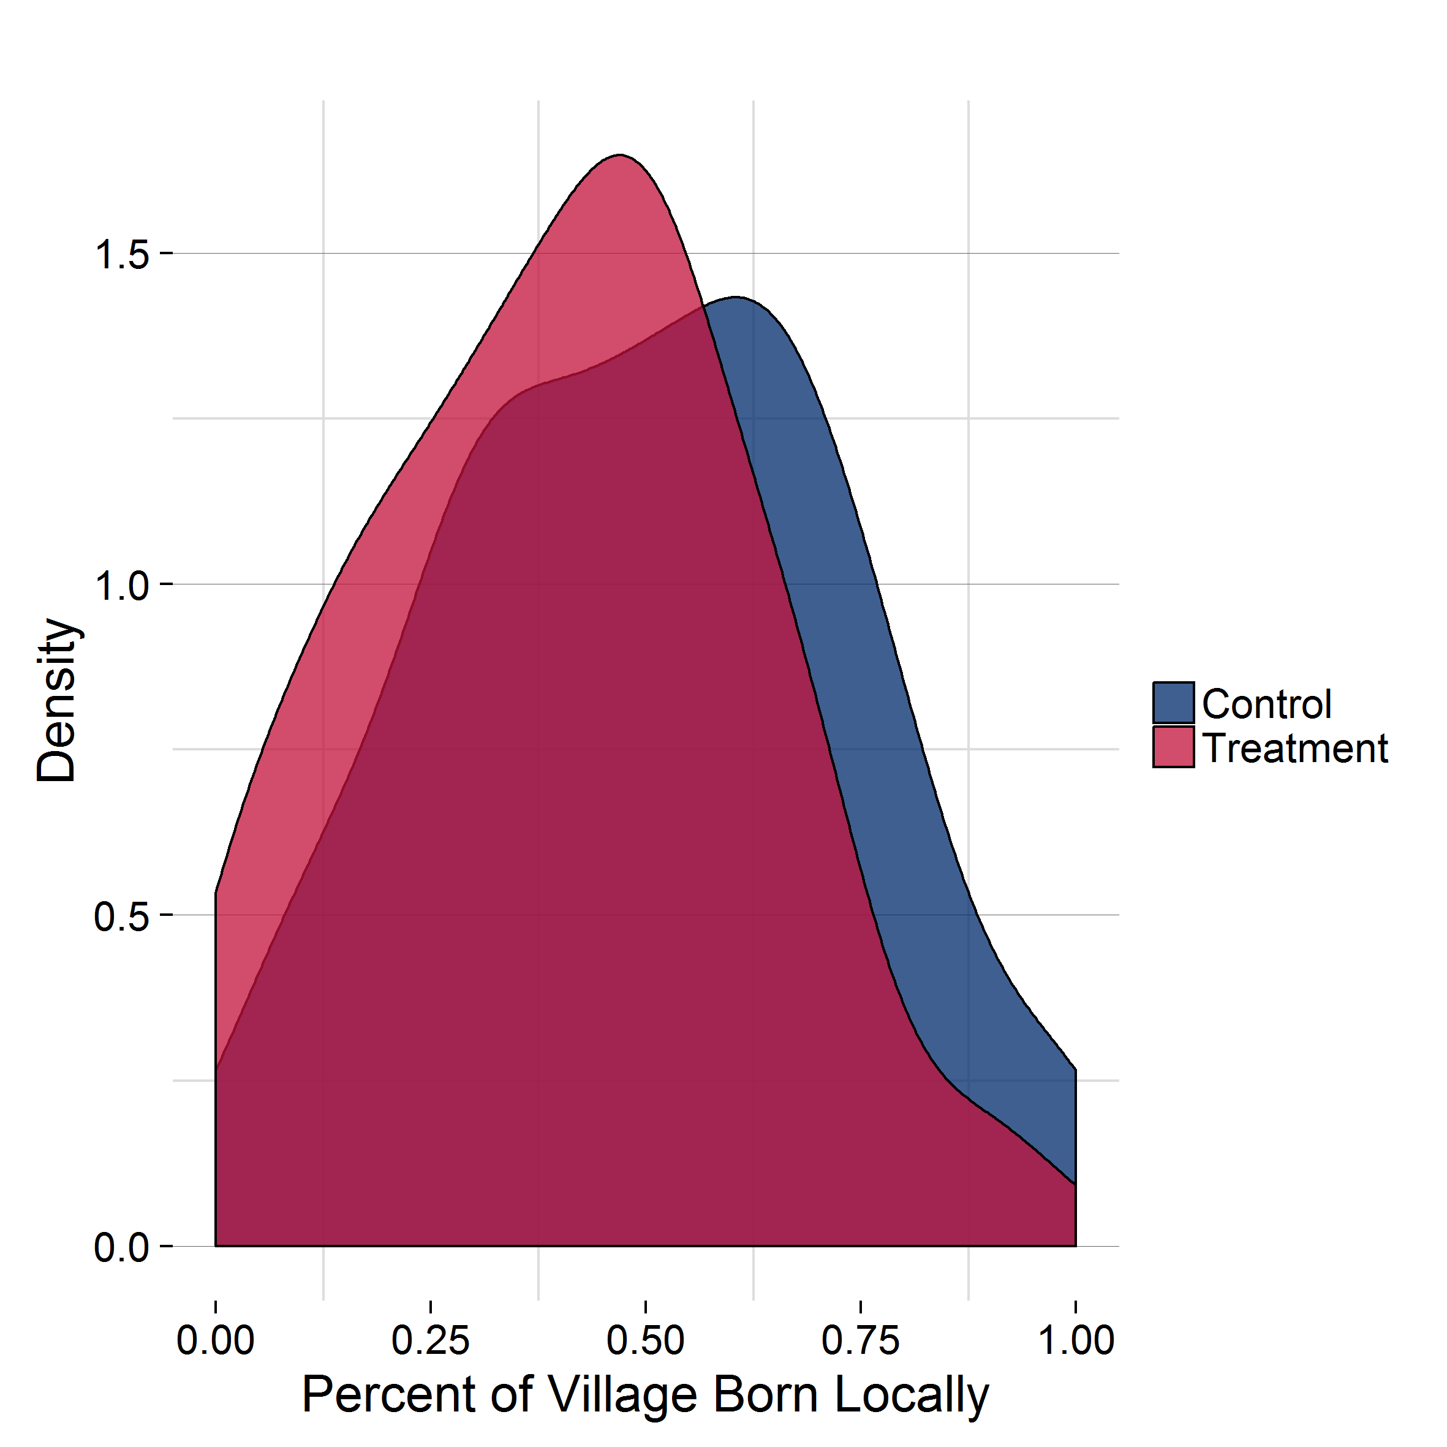
In each of the following sections, the first table will contain control variables describing demographic and asset data, income sources, and respondent reported climate and development issues. The second table presents expected outcome variables at baseline, including forest conditions, forest management and rules, and forest and land security. All variables are reported at either the respondent, or household level. Most variables are either reported as binary responses, or on a scale. With binary variables, a 0 is “No”, and 1 is “Yes,” for variables measured on a scale, lower values are generally more “positive” responses (e.g., “Strongly Agree”, or “Very Good”), and higher values are more “negative” (e.g., “Strongly Disagree”, or “Very Bad”). The socioeconomic status (SES) variable is generated using asset, livestock, and land data, where a lower value indicates a respondent with fewer of these resources.
Figure 8.1—Percent of Village Born Locally: Treatment versus control

TREATMENT AND CONTROL
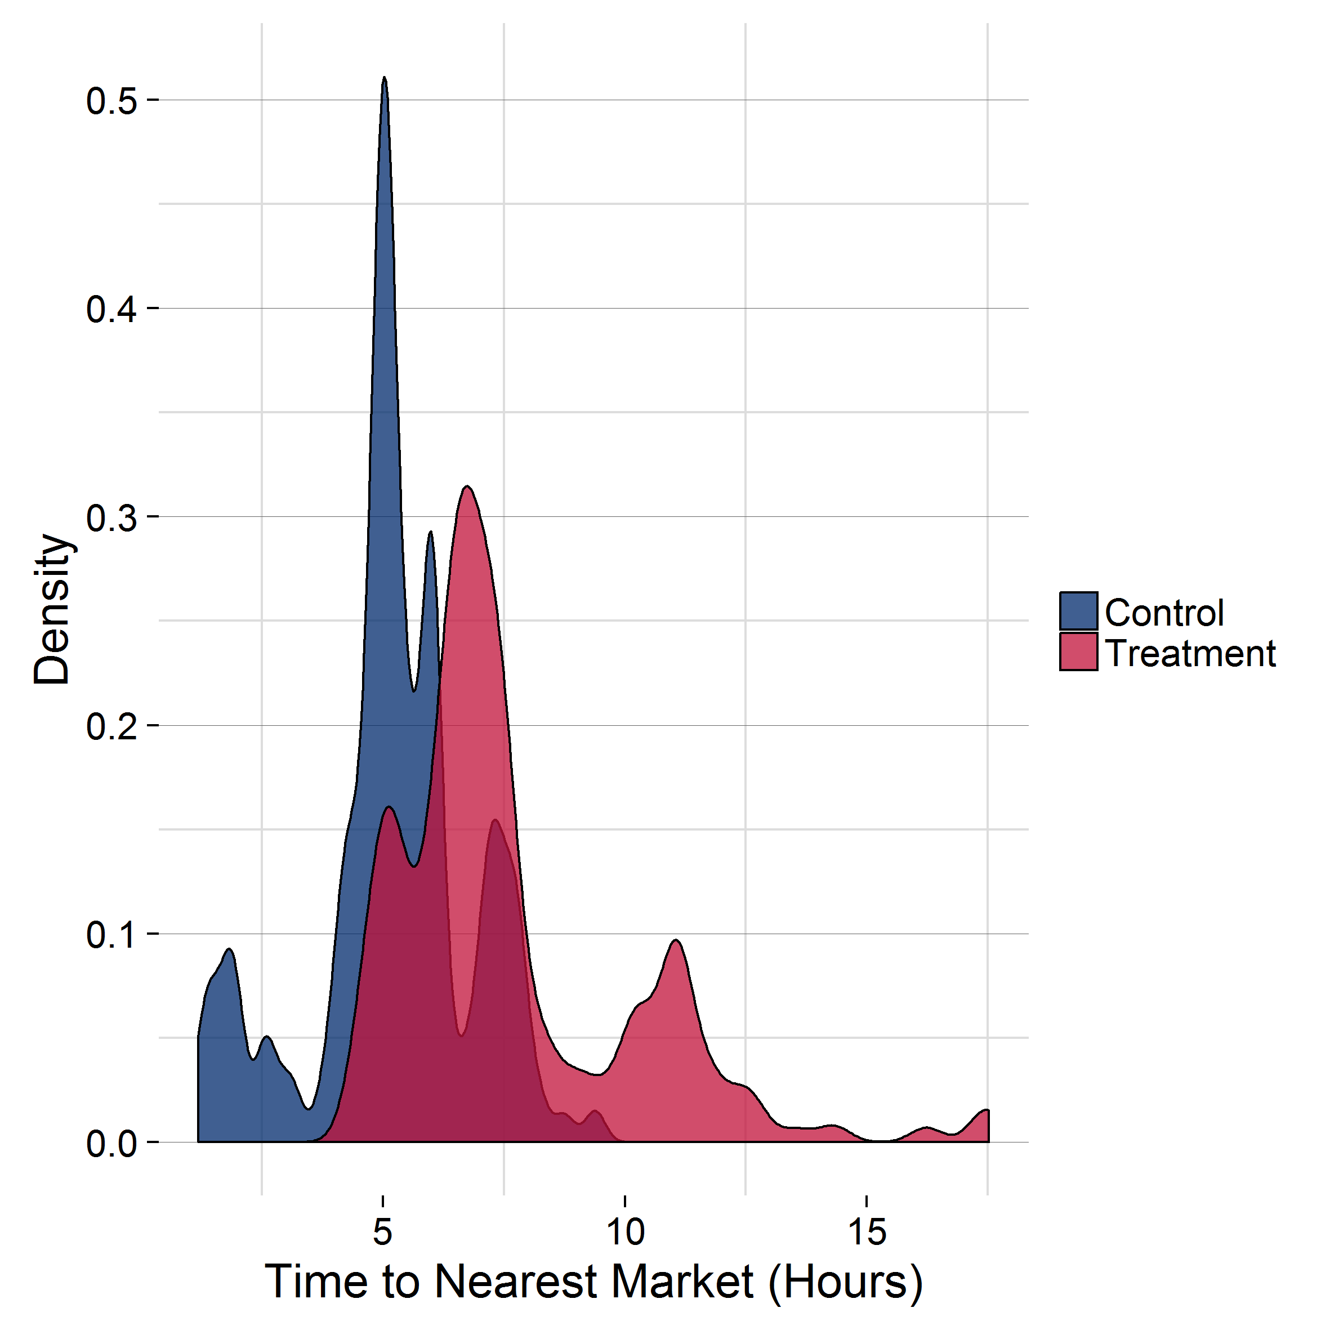
This IE covers 324 communities, of which 158 are treatment communities, and 163 are control. There are 2224 respondents in the treatment group, and 2119 in the control group, for a total of 4343 observations. Table 8.1 shows that there are variables with imbalance issues, mostly stemming from the fact that treatment households are more rural and depend more on agriculture. However, despite the statistical imbalance, the kernel density plots presented in Figures 8.1 and 8.2 show that there is still significant overlap, even for some of the most problematic variables.
Figure 8.2—Time to Nearest Market (Hours): Treatment versus Control
In the Household Information section, we see that households generally look the same. The main exception is that respondents in the control group are more likely to be born outside their current village (50%, N=1024), than those in the treatment group (41%, N=922). This appears to be a trend within the chiefdoms, and thus villages, selected for the control group (See Figure 8.1). There is also a slight difference in marital status between the groups, however it is significant at the 5% level, and of relatively small magnitude (i.e. the control group is 3% more likely to be married), and thus should not be an issue. Notably, none of these measures have a % bias above the 25% mark. Both household size and religion are different at the 10% level, but the magnitude and the % bias indicate that this is not a major difference to be concerned about. There are more prominent differences in the Household Income sections. Treatment households generate much more income from farming, and significantly less from trading and sale of forest products. While the % bias for these indicators is not above the 25% threshold, this does appear to be a significant difference, based on the regression estimates as well as results from other indicators. Additional variables examined for balance also indicate that treatment villages are more agrarian and remote.
Table 8.1—Household Demographics, Assets, Climate & Development Problems, and Income
 | Treatment | Cluster S.E. | Constant | Cluster S.E. | N | % Bias
Household Information
Respondent Age | -0.21 | 0.74 | 40.92*** | 0.56 | 3399 | 1.29%
Respondent Marital Status | -0.03** | 0.02 | 0.72*** | 0.01 | 4340 | 7.3%
Born in this Village | -0.08*** | 0.02 | 0.5 | 0.02 | 4336 | 16.73%
# of Children in HH | 0.07 | 0.1 | 4.16*** | 0.07 | 4342 | 2.38%
Household Size | 0.16* | 0.09 | 5.14*** | 0.07 | 4342 | 5.81%
Religion | -0.04* | 0.02 | 1.15*** | 0.02 | 4342 | 6.64%
Distance to Forest (Minutes) | 2.56 | 2.56 | 33.56*** | 1.72 | 3583 | 5.62%
Household Income Sources
Farming | 145.26*** | 39.84 | 353.76 | 28.42 | 4262 | 14.16%
Tourism | -1.42 | 10.84 | 26.99*** | 7.58 | 4328 | 0.48%
Salaried Job | -30.9 | 21.78 | 120.48*** | 18.05 | 4288 | 5.07%
Petty Trade | -71.9** | 29.08 | 253.19 | 23.5 | 4303 | 9.64%
Livestock | -14.92 | 11.01 | 77.55*** | 8.95 | 4330 | 4.45%
Sale of Forest Products | -90.37*** | 19.97 | 106.03 | 19.77 | 4333 | 23.6%
Forest Activities (e.g., patrolling, guiding, carbon payments) | -4.06 | 3.29 | 6.13** | 2.97 | 4340 | 3.76%
Household Assets and Socioeconomic Status
Number of Electronics | -0.21*** | 0.08 | 1.29 | 0.07 | 4342 | 10.53%
Number of Farming Tools | 0.09 | 0.12 | 4.17*** | 0.09 | 4342 | 2.94%
Number of Large Livestock | 0.73*** | 0.22 | 1.31 | 0.15 | 4342 | 15.07%
Number of Small Livestock | 0.87** | 0.41 | 6.5 | 0.31 | 4342 | 8.33%
Number of Meat Meals/Week | -0.45*** | 0.09 | 1.61 | 0.07 | 4341 | 21.71%
Socioeconomic Status | -0.01 | 0.01 | 0.25*** | 0.01 | 4342 | 3.49%
Climate Challenges
Drought in Past Year | 0.03 | 0.02 | 0.45*** | 0.02 | 4302 | 6.92%
Erratic Rains in Past Year | -0.03 | 0.02 | 0.34*** | 0.02 | 4318 | 6.09%
Flood in Past Year | 0.01 | 0.01 | 0.05*** | 0.01 | 4314 | 6%
Development Challenges
Forest Degradation | 0.03 | 0.09 | 1.18*** | 0.06 | 4342 | 1.91%
Inconsistent Rains | 0.09 | 0.09 | 3.12*** | 0.06 | 4342 | 4.77%
No Jobs | -0.48*** | 0.09 | 2.51 | 0.07 | 4342 | 26.03%
Scarce Food | -0.37*** | 0.09 | 2.97*** | 0.06 | 4342 | 18.97%
Bad Roads | 0.42*** | 0.12 | 1.9 | 0.1 | 4342 | 23.1%
Distance to Market (Hours) | 2.45*** | 0.26 | 5.22 | 0.15 | 3714 | 115.53%

The asset and development challenges sections show corresponding patterns. While the Socioeconomic Index is not significantly different between the groups, the assets held by each group are different. The treatment group reports fewer electronics (significant at the 5% level), and more livestock, both small and large. They also report fewer meals containing meat per week. These results are consistent with the treatment group being more agrarian.
The climate challenges section reveals no difference in reported drought, erratic rainfall, and flooding, however the groups do report different development problems. The control group is more likely to view food and job scarcity as major development problems, both significant at the 1% level, with a high % bias. The treatment group is more concerned about the quality of roads, likely because the distance to nearest market is substantially different across the two groups (both significant at the 1% level). In the control group, the mean travel time is 5.2 hours, with a minimum of 1.2 hours, and a max of 9.3 hours. In the treatment group, the mean is 7.67 hours, with a minimum of 4.4 hours, and a max of 17.5 hours. See Figure 8.2 for a visual representation of this.
Table 8.2 below compares treatment and control groups on forest and land condition, management, and expropriation indicators.
With respect to current forest conditions, treatment households are more likely to both report negative change in forest conditions, and new forest restrictions. Both of these indicators are significantly different at the 5% level, and have a high enough standardized difference in means to indicate that there is significant imbalance here. Likewise, the treatment group is more likely to report having both a forest management group (this is a group that is not necessarily associated with the village), and a village forest committee, with a high statistical significance, and difference in means. However, treatment respondents are also less confident that their village leaders will not sell forest land without village consensus, and more worried about investors.
Land related variables also indicate that treatment households are more agrarian. In particular, treatment households have more fields, and actively clear more fields. Likewise, treatment respondents are less likely to see land leaders and land rules as fair, though they are more likely to report village land meetings. Finally, we see that treatment respondents are generally more worried about encroachment within their village, either by their neighbors, investors, or extended family. However, as for the household characteristics examined in Table 8.1, the standardized difference in means for nearly all of the forest and land-related variables reported in Table 8.2 indicate little to no major imbalances across households in the treatment and control groups on these factors. The balance checks suggest that there is sufficient overlap in the distributions across the two groups on these key potential confounding factors to obtain a strong control group of households for the endline analysis via the planned DD coupled with matching analytic approach.

Table 8.2—Forest and Land Measurements
 | Treatment | Cluster S.E. | Constant | Cluster S.E. | N | % Bias
Current Forest Conditions and Rules
Current Forest Condition | 0 | 0.07 | 2.5*** | 0.05 | 3562 | 0.23%
Forest Condition Change in Past 3 Years | 0.1** | 0.05 | 3.48*** | 0.03 | 3583 | 10.55%
New Restrictions in Past Year | 0.04** | 0.02 | 0.14 | 0.01 | 3553 | 10.76%
Permit Required to Collect Forest Products | -0.03 | 0.02 | 2.89*** | 0.01 | 3530 | 7.41%
Climate and Forest Valuation
Predictable Rain is Important for Dev. | -0.16 | 0.13 | 8.04*** | 0.09 | 4334 | 5.86%
Preventing Forest Degradation is Important for Dev. | 0.15 | 0.15 | 5.5*** | 0.11 | 4327 | 4.64%
Forest Protection is Important for Dev. | -0.05* | 0.03 | 1.7*** | 0.02 | 4178 | 7.74%
Forest Leadership and Rules
Satisfied with Forest Leaders | 0.07 | 0.04 | 1.91*** | 0.03 | 4150 | 6.87%
Forest Leaders Protect Forests | 0.04 | 0.04 | 1.92*** | 0.03 | 3990 | 3.87%
Forest Leaders are Fair | 0.08* | 0.04 | 2.01*** | 0.03 | 3993 | 7.87%
Forest Use Rules are Fair | 0.08* | 0.04 | 2.01*** | 0.03 | 3913 | 8.54%
Forest Access Rules are Fair | 0.06 | 0.04 | 2.01*** | 0.03 | 3925 | 6.7%
Village Forest Management
Village Holds Forest Meetings | 0.03* | 0.02 | 0.14 | 0.01 | 4158 | 8.66%
Forest Management Group in Area | 0.04*** | 0.01 | 0.06 | 0.01 | 4242 | 13.35%
Village has Forest Committee/Group | 0.04*** | 0.01 | 0.03 | 0 | 4237 | 16.89%
Forest Ladder of Power: Women | 0.13 | 0.12 | 4.24*** | 0.09 | 4342 | 4.86%
Forest Ladder of Power: Village as a Whole | -0.02 | 0.12 | 4.44*** | 0.09 | 4342 | 0.87%
Likelihood of Forest Encroachment Scenarios
Outside Elites will Encroach on Forests | 0.08 | 0.09 | 2.22*** | 0.06 | 3539 | 4.37%
Chief Will Sell Forest Land w/o Village Approval | 0.29*** | 0.1 | 2.58 | 0.07 | 3536 | 14.74%
Investors Will Encroach on Forests | 0.18** | 0.09 | 2.22 | 0.06 | 3539 | 10.14%
Government Officials Will Encroach on Forests | 0.14 | 0.09 | 2.62*** | 0.06 | 3529 | 7.4%
Household Field Information
Number of Fields Used by HH | 0.32*** | 0.06 | 1.79 | 0.05 | 4342 | 28.89%
Number of Recently Cleared Fields | 0.04*** | 0.01 | 0.09 | 0.01 | 4342 | 10.11%
Land Leadership and Rules
Satisfied with Land Leaders | 0.07* | 0.03 | 1.73*** | 0.02 | 4297 | 8.06%
Land Leaders are Fair | 0.15*** | 0.04 | 1.74*** | 0.02 | 4217 | 16.82%
Land Rules are Fair | 0.13*** | 0.04 | 1.76*** | 0.02 | 4185 | 15.49%
Village has Land Committee | 0.02 | 0.01 | 0.06*** | 0.01 | 4280 | 6.23%
Village has Land Meetings | 0.03** | 0.01 | 0.1 | 0.01 | 4283 | 8.81%
Land Ladder of Power: Women | 0.05 | 0.12 | 4.56*** | 0.08 | 4342 | 1.81%
Land Ladder of Power: Village as a Whole | -0.03 | 0.12 | 4.8*** | 0.09 | 4342 | 1.19%
Satisfied with Land Leaders | 0.07* | 0.03 | 1.73*** | 0.02 | 4297 | 8.06%
Likelihood of Land Encroachment Scenarios
Village Neighbors will Encroach on Land | 0.15** | 0.07 | 1.94*** | 0.04 | 4110 | 9.99%
Elites will Encroach on Land | 0.11 | 0.07 | 1.94*** | 0.05 | 4106 | 7.28%
Neighboring Village will Encroach on Land | 0.11* | 0.06 | 1.89*** | 0.04 | 4112 | 7.46%
Chief will Give Land to Investors | 0.28*** | 0.09 | 2.33 | 0.06 | 4107 | 15.36%
Village Head will Reallocate Land | 0.12* | 0.07 | 1.86 | 0.04 | 4114 | 8.69%
External Family will Take Land | 0.18** | 0.09 | 2.04 | 0.06 | 4119 | 11.35%

POWER ANALYSIS
In this section we update the power calculations by calculating intra-class correlation (ICC) directly from the sample, for several key outcome variables. The household-level variables used here reflect many of the expected outcome indicators for CFP. Note that some of the variables, such as the encroachment variables, are synthesized from several variables. At the IE design stage, we necessarily conducted the power analyses using approximated ICC values in the absence of actual data. Please refer to Annex I—CFP IE Design Report for more detail on the initial calculations. Using the updated ICC values, we have a stronger sense of how well this IE will be able to detect treatment changes.
The household sample represents data from 4343 respondents, across 324 communities, with 162 in each arm of the study, and an average of ~13 respondents in each community. In Table 8.3 we present the updated, expected Minimum Detectable Effect Size (MDES) for several variables. Because of the interaction between ICC, MDES, and slightly different response rates for variables, the power of this study varies across indicators. We will focus on variables which are likely good indicators of our outcomes of interest at the household level. These are, in short, (1) fewer conflicts, (2) improved capacity to manage forests, (3) improved forest conditions, (4) greater tenure security and protection of forests, (5) higher perceived value of forests, (6) equitable benefit sharing across key subgroups, (7) improved customary governance institutions, (8) greater tenure security and protection of household land, (9) increased knowledge and awareness about deforestation, and (10) improved livelihood and welfare. Please see the IE design report for further detail.
The IE Design report estimated that with 150 communities in each arm of the study, 15 observations from each community, and an ICC of 0.15, we would have an MDES of 0.15. Using the baseline data, we see that the actual ICC for village clusters ranges from 0.03 to 0.13, with an average of 0.09. We have MDES values ranging from 0.14 to 0.20, with an average of 0.17.
The updated power analyses indicate the study may be somewhat less powered to detect fine-scale changes in forest condition change, forest area change, forest thickness change, and forest expropriation, as well as land expropriation and forest valuation, according to the outcome indicators constructed here, although the MDES values for these indicators are still well within the typical range of detectable effects for such studies. Taking into account the higher MDES values for these indicators, the pre analysis plan will further explore additional relevant indicators for these outcomes and any potential gains in detectable effect sizes that may be possible.
The updated power analysis shows that the evaluation is likely to be able to detect changes in the 3% to 28% range, with an average of 10%. By this measure, this IE is meeting design expectations. Overall, the study is sufficiently powered to detect moderate-sized, policy-relevant magnitudes of change at the household level. The pre-analysis plan will provide additional detail on power issues and expected detectable change by indicator.

Table 8.3—household power level analysis
 | μ | % | σ | ICC | MDES | Estimated detectable effect for CFP
Variable |  |  |  |  |  | Point Change | Percent Change
Conflict—Binary | NA | 2.22% | 0.15 | 0.03 | 0.14 | 0.02 | 3%
Village Forest Meetings—Binary | NA | 15.97% | 0.37 | 0.10 | 0.18 | 0.07 | 10%
Change in Forest Condition (Scale 1-5) | 2.47 | NA | 0.92 | 0.11 | 0.18 | 0.17 | 7%
Change in Forest Area (Scale 1-5) | 3.46 | NA | 0.86 | 0.12 | 0.19 | 0.16 | 5%
Change in Forest Thickness (Scale 1-5) | 3.43 | NA | 0.96 | 0.11 | 0.18 | 0.17 | 5%
Forest Expropriation Scenarios (Adj. Scale 1-5) | 2.50 | NA | 1.60 | 0.13 | 0.20 | 0.32 | 13%
Rank of Forest Resources (Scale 0-5) | 0.94 | NA | 1.53 | 0.09 | 0.17 | 0.26 | 28%
Women Disadvantaged by Forest Rules (Scale 1-5) | 3.61 | NA | 1.21 | 0.07 | 0.16 | 0.19 | 5%
Young Disadvantaged by Forest Rules (Scale 1-5) | 3.76 | NA | 1.11 | 0.07 | 0.16 | 0.18 | 5%
Poor Disadvantaged by Forest Rules (Scale 1-5) | 3.67 | NA | 3.67 | 0.07 | 0.16 | 0.59 | 16%
Forest Leaders are Fair (Scale 1-5) | 2.05 | NA | 1.00 | 0.08 | 0.17 | 0.17 | 8%
Forest Leaders are Trusted (Scale 1-5) | 1.93 | NA | 0.94 | 0.07 | 0.16 | 0.15 | 8%
Land Expropriation Scenarios (Adj. Scale 1-5) | 2.08 | NA | 1.30 | 0.13 | 0.20 | 0.26 | 12%
Level of Household Income (Scale 1-5) | 1.45 | NA | 0.83 | 0.04 | 0.15 | 0.12 | 9%

REFERENCES

Caeyers, B., Chalmers, N., & de Weerdt, J. (2010). A Comparison of CAPI and PAPI Through a Randomized Field Experiment. Retrieved from http://ssrn.com/abstract=1756224
Corbera, E. (2012). Problematizing REDD+ as an experiment in payments for ecosystem services. Current Opinion in Environmental Sustainability.
Corbera, E., & Schroeder, H. (2011). Governing and implementing REDD+. Environmental Science and Policy.
Kalinda, T., Bwalya, S., Mulolwa, A., & Haantuba, H. (2008). Use of Integrated Land Use Assessment (ILUA) data for forestry and agricultural policy review and analysis in Zambia. Zambia Forestry Department and FAO. Retrieved from http://www.fao.org/forestry/16955-0c90798cee1e59a8542ede210a9834227.pdf
Larson, A. M., Brockhaus, M., Sunderlin, W. d., Duchelle, A., Babon, A., Dokken, T., . . . Huynh, T.-B. (2013). Land tenure and REDD+: The good, the bad and the ugly. Global Environmental Change, 23, 678-689. doi:10.1016/j.gloenvcha.2013.02.014
Mahanty, S., Suich, H., & Tacconi, L. (2013). Access and benefits in payments for environmental services and implications for REDD+: Lessons from seven PES schemes. Land Use Policy, 31, 38-47. doi:doi:10.1016/j.landusepol.2011.10.009
Ministry of Tourism, Environment and Natural Resources . (2002). Zambia National Action Programme for combating Desertification & Mitigating serious effects of Drought in the Context of the United Nations Convention to Combat Desertification. Retrieved from United Nations Convention to Combat Desertification (UNCCD): http://www.unccd.int/ActionProgrammes/zambia-eng2000.pdf
Naughton-Treves, L., & Wendland, K. (2014). Land Tenure and Tropical Forest Carbon Management. World Development, 55, 1-6. doi:10.1016/j.worlddev.2013.01.010
Tembo, S., & Sitko, N. (2013). Technical Compendium: Descriptive Agricultural Statistics and Analysis for Zambia. Lusaka, Zambia: Indaba Agricultural Policy Research Institute (IAPRI). Retrieved from http://ageconsearch.umn.edu/bitstream/155988/2/wp76.pdf
UN-REDD. (2009). About the UN-REDD Programme. Retrieved from UN-REDD Programme: http://www.un-redd.org/AboutUN-REDDProgramme/tabid/102613/Default.aspx
USAID/Zambia. (2013). Economic Growth Projects Supporting Low Emission Development. USAID/Zambia. Retrieved from http://wbcarbonfinance.org/docs/biocf-Economic-Growth-Projects-for-LEDS-in-Luangwa-Valley-WB-workshop.pdf
Vinya, R., Kasumu, E. C., Syampungani, S., Monde, C., & Kasubika, R. (2011). Preliminary Study on the Drivers of Deforestation and Potential for REDD+ in Zambia. Lusaka, Zambia: Forestry Department and FAO. Retrieved from http://www.unredd.net/index.php?option=com_docman&task=doc_download&gid=8023&Itemid=53

U.S. Agency for International Development
1300 Pennsylvania Avenue, NW
Washington, DC 20523
Tel: (202) 712-0000
Fax: (202) 216-3524
www.usaid.gov

This IE is being implemented under USAID Contract Number AID-OAA-TO-13-00019, Evaluation, Research and Communication (ERC) Task Order under Strengthening Tenure and Resource Rights (STARR) IQC No. AID-OAA-I-12-00030.
To promote a standardized research and learning agenda across different land tenure interventions, many of the hypotheses tested in the CFP IE are also investigated across other IEs conducted under ERC as part of USAID’s land tenure IE portfolio.
Household respondents refer to the person answering the household survey, typically the head of household
Please refer to Section 8 for a detailed discussion of gender differences and similarities for the wives survey across key indicators.
“REDD+” goes beyond REDD (Reducing Emissions from Deforestation and Forest Degradation) to include sustainable forest management, conservation, and increasing forest carbon stocks.
To promote a standardized research and learning agenda across different land tenure interventions, many of the hypotheses tested in the CFP IE are also investigated across other IEs conducted under ERC as part of USAID’s land tenure IE portfolio.
BCPs’ model for CFP builds off the firm’s previous work in the Lower Zambezi REDD+ Project (LZRP). LZRP is Zambia’s first pilot REDD+ demonstration project; it was implemented on 38,781 ha of privately owned land in Rufunsa District. BCP expects learning from the CFP program model to feed into Zambia’s national planning for REDD+ and forest management.
Thirty years is the minimum number of years that a program must be in operation in order to show “permanence” for carbon credits.
Please see Annex I—CFP IE Design Report for more detailed information about the program interventions.
Community-based biomass and soil measurements are also collected throughout the life of the program to assess the health of the forest.
The VCS methodology will be followed for the quantification of carbon stocks and Net Emissions Reductions (NERs).
Benefit distribution through the sale of carbon credits is expected to take place after the proposed 2018 midline data collection, if at all (additional data collection will be subject to available funding and subsequent USAID approval).
Discussions of DD limitations in the literature include: endogeneity of interventions (Besley and Case 2000); isolation of specific behavioral parameters (Heckman 2000, Blundell and MaCurdy 1999); linearity assumption (Athey and Imbens 2002); and large standard errors (Bertrand et al. 2004).
Please refer to Annex I—CFP IE Design Report and Annex III—Balance and Power for a more detailed discussion of the strengths and limitations of the DD method for this evaluation.
Although matching could not be used for the selection of controls prior to sampling, matching methods will be used to pre-process the data for the final evaluation analyses.
Because chiefdom boundaries do not perfectly map onto district boundaries, some villages in Luembe and Nyalugwe chiefdom fall under Petauke district
For example, one rumor encountered by the survey team was that ‘BCP was going to steal the oxygen from the trees.’
A neighboring district of Eastern province
Interestingly, this group reports the lack of jobs being a major development problem less often than the rest of the sample but instead focuses on the scarcity of food.
Selling honey and bee keeping represent a set of activities that CFP hopes to bring to communities as part of Component 2—Livelihood Improvement.
In March 2015, ZAWA was merged with the Department of Tourism and is now the Department of National Parks and Wildlife
A significant number of respondents also ranked the headperson directly below the chief on the ladder—36% of respondents noted that the headperson was a ‘9’ on the ladder and 15% indicated ‘8’.
17% (755) of respondents strongly disagree or disagree that village leaders do not take bribes around forest issues.

